10ZiG UWF User Guide

Table of contents
Introduction 9
Prerequisites 10
Computer System Requirements: 11
Windows Level Requirements: 11
Authority Level Requirements: 12
10ZiG UWF Wizard Use 13
Status Icon 13
Accessing Configuration 14
Application Use 14
UWF/Shell Launcher Status/Keyboard Filter Service 17
User or Group Shell Launcher 20
User 20
Group 21
Shell 21
Optional Parameters 22
Unexpected Close 22
Default Shell 23
Sample User Shell 23
Sample Group Shell 24
Sample Default Shell 24
Shell Launcher Status 25
Shell Launcher Status Indicator 26
Default Shell 26
Enable/Disable button 27
Sample Shell Launcher Disable Status 27
Sample Shell Launcher Enable Status 28
UWF Status 28
Overlay Type 29
Maximum Size MB 29
Warning Threshold MB 30
Critical Threshold MB 30
Consumption MB 30
Available Space MB 30
Servicing State 31
Current Status 31
Next Status 31
Enable/Disable button 31
Microsoft Keyboard Filter Service 32
Microsoft Keyboard Filter 33
Sample Enable Microsoft Keyboard Service 34
Sample Disable Microsoft Keyboard Service 34
Custom Shells 35
Shell Keys 38
User/Group 40
SID 40
Shell 40
Close 41
Example Change User Shell 41
Example Change Group Shell 42
Example Delete User/Group Shell 43
Exclusion List 45
Recommended File/Registry Exclusions 48
Directory or File Exclusions 48
File 49
Example adding/removing file exclusion 49
Directory 50
Example adding/removing directory exclusion 50
Registry Exclusions 51
Example adding/removing registry exclusion 52
Example adding/removing registry exclusion UWF enabled 53
Page File 53
Windows 10 Enterprise 2016 LTSB 54
Page File Enable 55
Example Page File Enable 57
Example Page File Enable Error Message 58
Page File Disable 58
Example Page File Disable 60
UWF Servicing 60
Overlay Settings 61
Overlay storage 63
RAM-based overlay 64
Disk-based overlay 65
Overlay thresholds and notifications 65
Overlay exhaustion 66
Overlay Type 66
Example Overlay Type 67
Maximum Size for Overlay 68
Example Setting Maximum Size 68
Critical Threshold Size 69
Example Setting Critical Threshold Size 69
Warning Threshold Size 69
Example Setting Warning Threshold Size 70
Monitor Consumption and Space 70
Example of setting Monitor Consumption and Available Space 71
Welcome/Lock/Boot Screen 72
Disable Welcome Screen Animation 75
Example Turning Off Welcome Screen Animation 76
Example Turning On Welcome Screen Animation 77
Autologon Screen 77
Example Hiding Autologon Screen 78
Example Displaying Autologon Screen 79
Lock Screen 81
Example Hiding Lock Screen 81
Example Displaying Lock Screen 82
UI Verbosity Level 83
Example Hiding UI Verbosity Level 84
Example Displaying UI Verbosity Level 85
Welcome Screen UI Elements 86
Branding Neutral 87
Remove Power 91
Example Remove Power 93
Remove Language 94
Example Remove Language 96
Remove Ease of Access 97
Example Remove Ease of Access 99
Remove Block Shutdown Resolver 100
Example Remove Block Shutdown Resolver 102
Remove Switch User 103
Example Remove Switch User 105
Remove Network 106
Example Remove Network 108
Allow All UI Elements 109
Example Allow all UI Elements 113
Remove all UI Elements 114
Example Remove All UI Elements 118
Boot Screen User Interface 119
Boot GUI Screen 120
All Boot UI Removal 120
Example All Boot UI Removal 123
All Boot UI Allowed 124
Sample All Boot UI Allowed 126
Keyboard Filter 127
Keyboard Filter - Specific Keys 131
Accessibility Keys 133
Example Allow Accessibility key 134
Example Block Accessibility key 134
Example Allow All Accessibility keys 135
Example Block All Accessibility keys 136
Application Keys 137
Example Allow Application key 138
Example Block Application key 139
Example Allow All Application keys 140
Example Block All Application keys 141
Browser Keys 142
Example Allow Browser key 143
Example Block Browser key 144
Example Allow All Browser keys 145
Example Block All Browser keys 146
Modifier Keys 146
Example Allow Modifier key 148
Example Block Modifier key 149
Example Allow All Modifier keys 150
Example Block All Modifier keys 150
Security Keys 151
Example Allow Security keys 152
Example Block Security keys 153
Example Allow All Security keys 154
Example Block All Security keys 155
Keyboard Filter - Shell Keys 156
Shell Keys 161
Example Allow Shell key 164
Example Block Shell key 167
Example Allow All Shell keys 169
Example Block All Shell keys 171
Enable/Disable Filter Admins 173
Example Enabling Keyboard Filter Administrator Group 174
Example Disabling Keyboard Filter Administrator Group 175
Enable/Disable Accessibility 176
Example Enabling Accessibility 177
Example Disabling Accessibility 178
Keyboard Filter - All Keys 179
Example Allow key - All Keys 184
Example Block key - All Keys 188
Example Allow All - All Keys 192
Example Block All - All Keys 196
Glossary 200

Introduction

Introduction

The 10ZiG UWF Wizard is an application that allows you to make changes to the Unified Write Filter, Shell Launcher, Keyboard Filter and Welcome/Lock Screen. (All of these products are Windows Features in Windows IoT Enterprise.)

The Unified Write Filter allows you to protect your physical storage media, including most standard writable storage types that are supported by Microsoft Windows, such as physical hard disks, solid-state drives, internal USB devices, external SATA devices, and so on. You can also use UWF to make read-only media appear to the OS as a writable volume. UWF intercepts all write attempts to a protected volume and redirects those write attempts to a virtual overlay. This improves the reliability and stability of your device and reduces the wear on write-sensitive media, such as flash memory media like solid-state drives. The overlay does not mirror the entire volume, but dynamically grows to keep track of redirected writes. Generally, the overlay is stored in system memory, although you can cache a portion of the overlay on a physical volume.

Shell Launcher is an application that replaces the default Windows shell with a custom shell. You can use any application or executable as your custom shell, such as a command window or a custom dedicated application. You can also configure it to launch different shell applications for different users or user groups. Shell Launcher processes the Run and RunOnce registry keys before starting the custom shell, so your custom shell doesn't need to handle the automatic startup of other applications and services. The application also handles the behavior of the system when your custom shell exits. You can configure the shell exit behavior if the default behavior does not meet your needs.

Keyboard Filter is and application that allows you to suppress undesirable key presses or key combinations. Normally, a customer can use certain Microsoft Windows key combinations like Ctrl+Alt+Delete or Ctrl+Shift+Tab to alter the operation of a device by locking the screen or using Task Manager to close a running application. This may not be desirable if your device is intended for a dedicated purpose. The Keyboard Filter feature works with physical keyboards, the Windows on-screen keyboard and the touch keyboard. Keyboard Filter also detects dynamic layout changes, such as switching from one language set to another, and continues to suppress keys correctly, even if the location of suppressed keys has changed on the keyboard layout.

Overlay Settings is part of the Unified Write Filter (UWF) that protects the contents of a volume by intercepting write attempts to a protected volume and redirects those write attempts to a virtual overlay. You can choose where the overlay is stored (RAM or disk), how much space is reserved, and what happens when the overlay fills up.
To increase up-time, set up monitoring to check if your overlay is filling up. At certain levels, your device can warn users and/or reboot the device.

Welcome Screen is the first screen that appears when you turn on Windows. The Welcome screen lists all the accounts on the computer and has various icons in the lower right hand side that allow you to do various functions.

Lock Screen is part of Windows and is a security feature for computers and mobile devices that helps prevent unauthorized access to the device. Also known as a screen lock or lock screen, a screen lock requires a specific action or sequence of actions to be correctly performed by anyone attempting to use a lock screen protected device. It also lists all the accounts on the computer and has various icons in the lower right hand side that allow you to do various functions.

Boot Screen is part of Windows and is referred to as a boot screen, boot skin, or welcome screen. The splash screen is an introduction page that is displayed as a program or computer is loading or booting. It contains a (GUI) Graphical User Interface and has Advanced Key Options to change the way it can boot.

Prerequisites
Prerequisites:

This section contains the Computer System, Windows and Authority Level requirements to use the 10ZiG UWF Wizard.

Computer System Requirements:
Computer System Requirements:

The OS must be Windows IoT Enterprise LTSB 2015, Windows IoT Enterprise LTSB 2016 or Windows Enterprise LTSC 2019.

Both X86 and X64 architecture are supported.

See figure below:

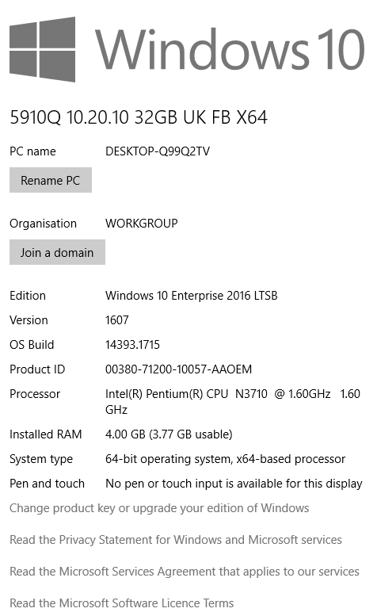

Windows Level Requirements:
Windows Level Requirements:

The entire Device Lockdown feature must be enabled in Windows: See Below:

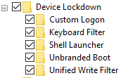

This can be found in the control panel under programs and features.

Turn on or off windows features

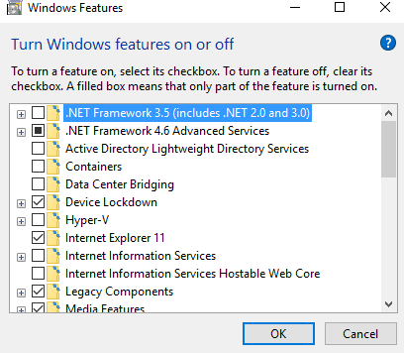

Authority Level Requirements:
Authority Level Requirements:

The user who wants to make changes to UWF or Shell Launcher must have Administrative Privileges.

See figure below:

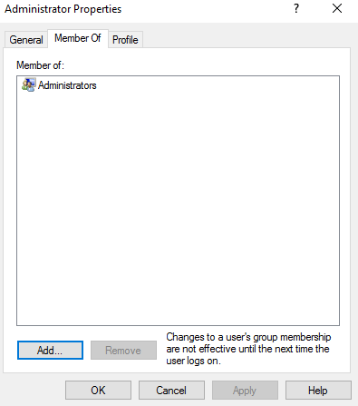

10ZiG UWF Wizard Use
10ZiG UWF Wizard Use:

This section will go over the status icon and how to access configuration.

Status Icon
Status Icon

The 10ZiG UWF Wizard automatically starts and has an icon in the system tray.

The icon has two colors.

Green means the image is not protected and red the image is protected.

See below:

Not protected -

Protected -

Accessing Configuration
Accessing the configuration

You can access the 10ZiG UWF Wizard in two ways:

- Double-click the status icon

- Right-click the status icon and a context menu will be shown as seen below:

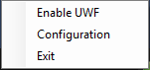

- The user must belong to the Administrator Group to access any functionality of the wizard. If not an error will be displayed.
- Notice that depending on the status of UWF the Disable/Enable command button will change accordingly. You can enable or disable UWF from this menu as well.
- You can also exit the UWF Wizard Tool. Please note that once the thin client is rebooted the UWF Wizard tool will run again.

Application Use
Application Use

This section explains how to use and setup the 10ZiG UWF Wizard.

The sections are as follows:

  - UWF/Shell Launcher Status/Keyboard Filter Service
  - Custom Shells
  - Exclusion Lists
  - Overlay Settings
  - Welcome/Lock/Boot Screens
  - Keyboard Filter
    - Keyboard Filter - Specific Keys
    - Keyboard Filter - Shell Keys
    - Keyboard Filter - All Keys

See application below:

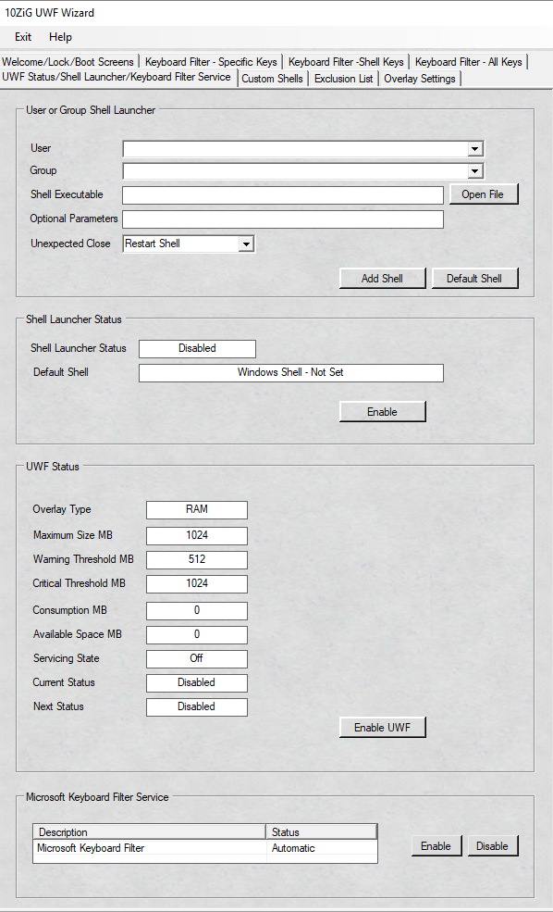

UWF/Shell Launcher Status/Keyboard Filter Service
UWF Status Shell Launcher

The first tab on the 10ZiG UWF Wizard is the User or Group Shell Launcher, Shell Launcher Status, UWF Status and Microsoft Keyboard Filter Service.

This tab provides configuration and information regarding Unified Write Filter (UWF), Shell Launcher and Microsoft Keyboard Filter Service.

Below is a snap shot of the first tab of the application.

We will break this into each section.

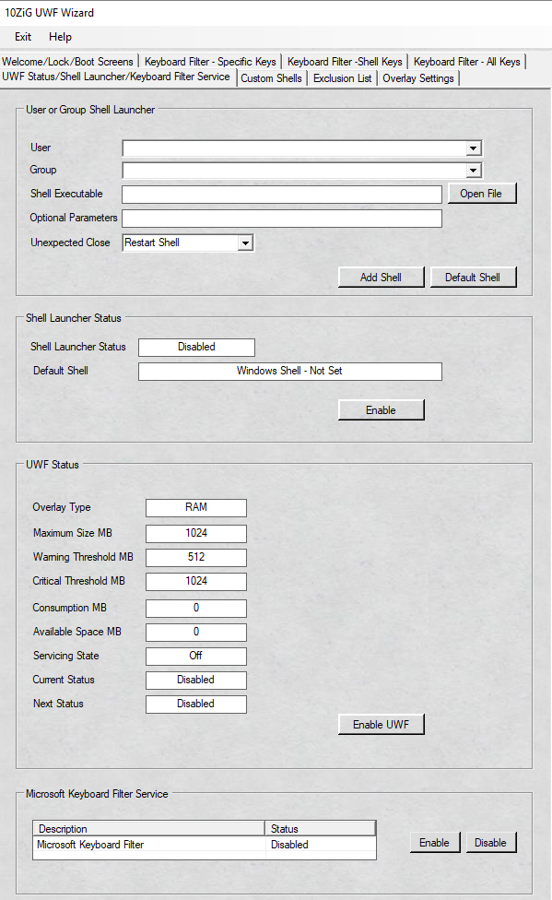

User or Group Shell Launcher
User or Group Shell Launcher

This section allows you to define users or groups with a specific custom shell as well as the standard default shell.

If needed, you have the option to add parameters to launch the custom shell.

There are options on handling an unexpected close of the shell as well.

There is a breakdown below of each field.

Below is the section this is referring to:

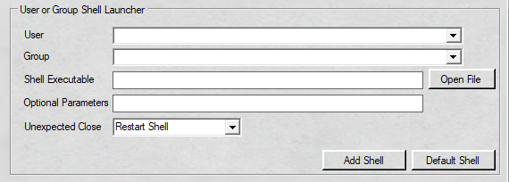

User
This field is a drop down list box of all users that exist on the thin client.
Please note that if you want domain users, the thin client must be joined to the domain first to acquire that information.
The user must exist on the OS for it to be used with a custom shell.
Simply click the drop down arrow and select the user you want to have a custom shell.

Group
This field is a drop down list box of all the groups that exist on the thin client.
Please note that if you want domain groups, the thin client must be joined to the domain first to acquire that information.
The group must exist on the OS for it to be used with a custom shell.
The group is used when you have different groups that need different shells.
For example, the Accounting group needs a financial application as their shell whereas the Sales group may need a completely different application.
Instead of setting up several users one at a time, you can use groups.
This makes it easier to manage and change.
Simply click the drop down arrow and select the group you want to have a custom shell.

Shell Executable
A read only field you must use the button "Open File" and browse to the path where the application is.
Therefore, the application must be installed on the system.
The shell path can be an .exe, .bat or script file etc.
Simply click the "Open File" command button and browse to the desired path as shown below:

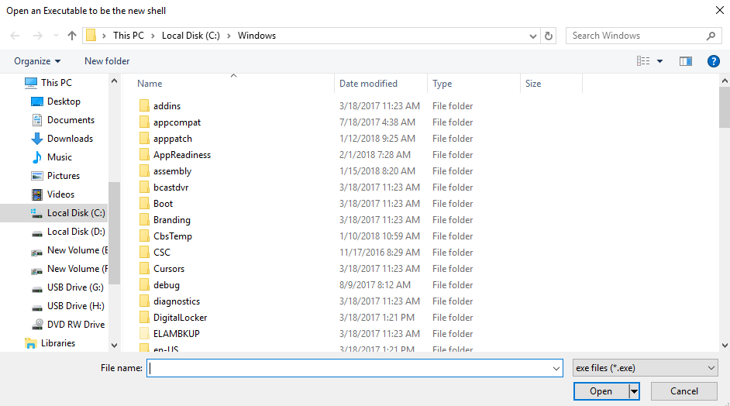

Once you have the shell you want to set as the default, click it and then click open.

Optional Parameters
Is a text field to add additional parameters to launch with the shell.
For example, if you wanted to launch a web browser in kiosk mode with a specific URL you would do that in this field.
An example would be –k http://www.yourURL.com

Unexpected Close
A Drop down list box of three options of how to handle an unexpected close of the custom shell you are choosing to launch.
The options are:
  - Restart Shell – Restarts the custom shell executable with optional parameters (if applicable) if the shell is exited.
  - Restart System – The operating system will perform a shutdown and restart if the custom shell is exited.
  - Shutdown System – The operating system will perform a shutdown of the system if the custom shell is exited.
  - Do Nothing - Nothing will happen if the custom shell is closed.

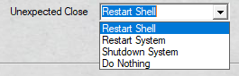

Default Shell

When you use shell launcher and have it enabled you must set a default shell.

The default shell defines any user that is not assigned a custom shell will use the default shell.

It is highly recommended by 10ZiG Technology to set the default shell to
c:\windows\explorer.exe

You will need to use the shell path and if applicable the optional parameters section and click the command button named default shell.

See below:

Sample User Shell

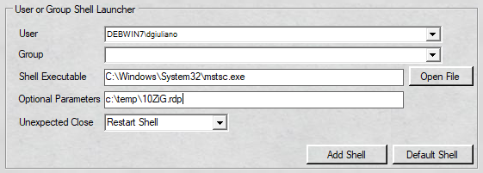

The sample above will have user "dgiuliano" launch the RDP Client using the specific 10ZiG.rdp file.

Sample Group Shell

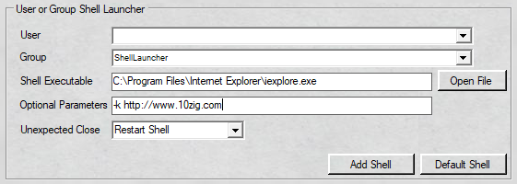

The sample above will have the group "ShellLauncher" use Internet Explorer launching to the 10ZiG website in Kiosk mode.

So any user belonging to the user group shell launcher will launch this.

Sample Default Shell

Simply click the "Open File" command button and browse to the desired path as shown below:

Once you have the shell you want to set as the default, click it and then click open.

Path will appear as shown below:

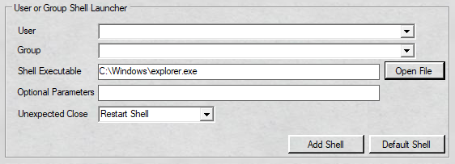

Now click the "Default Shell" command button to apply Windows Explorer as the default shell.

You will need to reboot for the changes to take effect.

Please note that 10ZiG highly recommends setting the default shell to c:\windows\system32\explorer.exe

Shell Launcher Status
Shell Launcher Status

This section is designed to be informative.
It displays the status of Shell Launcher and what the Default Shell is set to.
A command button will appear depending on the status of Shell Launcher.
There is a breakdown below of each field.
Below is the section this is referring to:
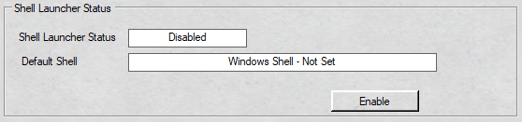

The criteria being discussed:

  - Shell Launcher Status
  - Default Shell
  - Enable/Disable Button

Shell Launcher Status

it is a read only text box that displays the status of Shell Launcher.
There will only be two possible statuses.
Enabled means the Shell Launcher status is in use and will use the custom shells chosen.
Disabled which means Shell Launcher is not running and the Windows Explorer shell will be used.

Default Shell

This is a read only text box that displays the current Default Shell assigned for any users not assigned a custom shell.
Please note: It is highly recommended that you set the default shell to
c:\windows\explorer.exe or at least the Administrator.
If you do not you could lose the ability to enter back into Windows to make any changes.

Enable/Disable Button

It is a command button that will be dependent upon the status of Shell Launcher.
For example, if the status is enabled then only a "Disable" button will appear.
For example, if the status is disabled then only a "Enable" button will appear.
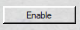

Sample Shell Launcher Disable Status

The above sample, displays that Shell Launcher is disabled and the Default Shell is not currently set.
The command button is set to "Enable" if you want to turn on Shell Launcher.

Sample Shell Launcher Enable Status

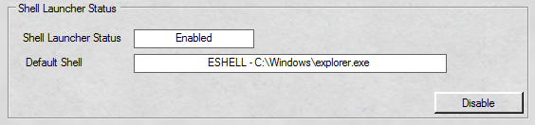

The above sample, displays that Shell Launcher is enabled and the Default Shell is the normal Windows shell explorer.
Also, the command button is set to "Disable" if you want to turn off Shell Launcher.

UWF Status
UWF Status

This section contains read only fields that display information regarding the Unified Write Filter (UWF) status.
You can change some of the parameters on the Overlay Settings tab.
A command button will be displayed according to the current status of Unified Write Filter (UWF).
Below is the section being referred to.
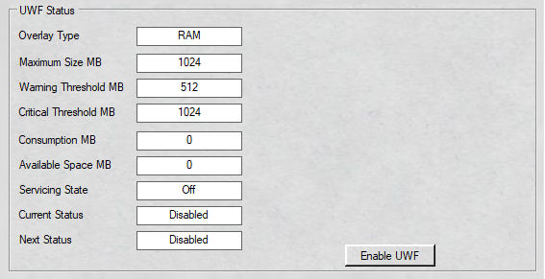

A further breakdown on what these fields are:
  - Overlay Type
  - Maximum Size MB
  - Warning Threshold MB
  - Critical Threshold MB
  - Consumption MB
  - Available Space MB
  - Servicing State
  - Current Status
  - Next Status
  - Enable/Disable Button

For a detailed explanation on these fields, please see the Overlay section.

Overlay Type
Overlay Type

There are two types of overlays RAM and Disk based.
By default RAM based is used on the thin client image.
The text box displays the current type of the UWF overlay in use.

To set the overlay type, go to overlay settings tab.

Maximum Size MB

The text box displays the current maximum size set in megabytes for the UWF Overlay.

The default maximum size set in the image is 1024 megabytes.

To change the Maximum Size go to the overlay settings tab.

Warning Threshold

Displays the warning threshold that will trigger the unified write filter to write an event to the event viewer.

The default warning threshold size set in the thin client image is 512 megabytes.

To change the warning threshold size, go to the overlay settings tab.

Critical Threshold

Displays the critical threshold that will trigger the unified write filter to write an event to the event viewer.

The default critical threshold size set in the thin client image is 1024 megabytes.

To change the critical threshold size, go to the overlay settings tab.

Consumption

Displays the current consumption space being used by the overlay in megabytes.

The unified write filter must be enabled to see a value.

The size is shown in megabytes.

Available Space

Displays the current available space left for the overlay in megabytes.

The Unified Write Filter must be enabled to see a value.

The size is displayed in megabytes.

Servicing State

Displays the current UWF servicing state.

Two values are available on or off.

Current Status

Displays the current status of the Unified Write Filter (UWF).

Only two statuses available:

Enabled or Disabled.

Next Status

Displays the next status of the Unified Write Filter after a reboot.

Only two statuses available:

Enabled or Disabled.

Enable/Disable Button

The button will change accordingly to the status of the Unified Write Filter giving you the ability to change the current status.

Options available:

Enable or Disable

The command button will be dependent upon the status of the current status of UWF.
For example, if the status is enabled then only a "Disable UWF" button will appear.
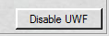
For example, if the status is disabled then only a "Enable UWF" button will appear.
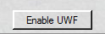

Just click the button to enable or disable the UWF.

Please note the thin client will need to reboot to make the changes.

You can also use Access Configuration to change the status of the UWF Write Filter.

Microsoft Keyboard Filter Service
Microsoft Keyboard Filter Service

This Microsoft Keyboard Filter Service controls the status of whether or not the Keyboard Filter is being used by the OS.
You can use Keyboard Filter to suppress undesirable key presses or key combinations. Normally, a customer can use certain Microsoft Windows key combinations like Ctrl+Alt+Delete or Ctrl+Shift+Tab to alter the operation of a device by locking the screen or using Task Manager to close a running application. This may not be desirable if your device is intended for a dedicated purpose.
The Keyboard Filter feature works with physical keyboards, the Windows on-screen keyboard, and the touch keyboard. Keyboard Filter also detects dynamic layout changes, such as switching from one language set to another, and continues to suppress keys correctly, even if the location of suppressed keys has changed on the keyboard layout.
The section shows you the current status of the Microsoft Keyboard Filter Service.
When the service is active the keyboard filter is being used. When the status is disabled the keyboard filter is not being used.

Below is the section being referred.
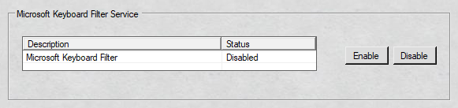

Microsoft Keyboard Filter
Microsoft Keyboard Filter

The section shows you the current status of the Microsoft Keyboard Filter Service.
The column description shows the Microsoft Keyboard Filter
The second column shows the current status in the OS.
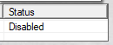
In the section below the current status is "Disabled". This means the keyboard filter is not running nor will it be started.

Sample Enable Microsoft Keyboard Filter

To enable the Microsoft Keyboard Filter, click the line containing the name and status and click the button "Enable".
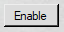

The service will automatically be change to "Automatic" which means that every time the OS is signed in the service will start.
It also will start the service immediately once the "Enable" button is clicked.
An updated status will be shown when the service startup has been changed and started
Sample shown below:
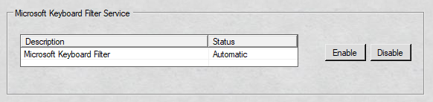

Sample Disable Microsoft Keyboard Filter

To disable the Microsoft Keyboard Filter, click the line containing the name and status and click the button "Disable".
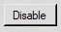

The service will automatically be change to "Disabled" which means that every time the OS is signed in the service will not be started.
It also will stop the service immediately once the "Disable" button is clicked.
An updated status will be shown when the service startup has been changed and started
Sample shown below:

Custom Shells
Custom Shells

This tab shows all the custom shells defined on the thin client.

It displays both user and group shells.

Simply highlight the row you want to delete/change to update/remove the current shell.

See figure below for reference.

Shell Keys

Shell Keys
Shell Keys

This displays by row the current custom shells defined on the thin client.

We will break down the row fields as well as the command buttons.

User/Group – Shows the user or group whether domain or local that has a defined custom shell.

SID – Shows the unique security identifier given by Windows.

Shell - Shows the full custom shell path that is running including any optional parameters given for that user or group.

Close – Shows the unexpected close option to be taken if the custom shell is exited.

There are three options:

  - Restart Shell
  - Restart System
  - Shutdown System
  - Do Nothing

Change Shell button for a user – This command button allows you to change the currently highlighted row.

You can only change the custom shell path, optional parameters and unexpected close.

Change Shell button for a group – This command button allows you to change the currently highlighted row.

You can only change the custom shell path, optional parameters and unexpected close.

Delete Shell button – This command button allows you to remove the currently highlighted row.

See below:

User

Shows the user or group whether domain or local that has a defined custom shell.

See sample below:

In the above sample the user is "DEBWIN7\defaultuser0"

In the above sample, the group is "DEBWIN7\Shell Launcher"

SID

Shows the unique security identifier given by Windows.

See the sample below:

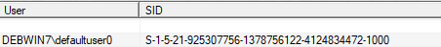

The SID for "DEBWIN7\dgiuliano" is displayed above.

Shell

Shows the full custom shell path that is running including any optional parameters given for that user or group.

User

In the above example, user "DEBWIN7\dgiuliano" is using the browser Internet Explorer running a specific web page and its optional parameters launching the custom shell in KIOSK mode.

Group

In the above example, the group "DEBWIN7\Shell Launcher" is running no optional parameters just a custom shell of the registry application.

Close

Shows the unexpected close option to be taken if the custom shell is exited.

See sample below:

User

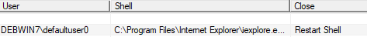

In the sample above, user "DEBWIN7\dgiuliano" uses the Internet Explorer application as its shell while running a specific web page in KIOSK mode and if the session is closed it will automatically restart the shell.

Group

In the sample above, the group DEBWIN7\Shell Launcher runs the registry application and if it is closed the system will shut down.

Example Change User Shell

To change a User's shell highlight the row that you need to change.

Click the "Change Shell" button.

You will see something similar as shown below:

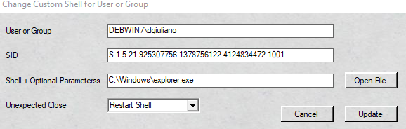

You can only change the shell with the optional parameters and/or unexpected close.

In this example, we are changing both the shell path and unexpected close.

To change the path, just click the "Open File" button and browse to the new path you need to use.

In this example, the change will be to use the VMware Horizon Client as the new shell for user "dgiuliano".

The next change will be the unexpected close.

Simply click on the drop down list box and change to the desired close.

In this example, when VMware Horizon Client is closed we want the system to shutdown.

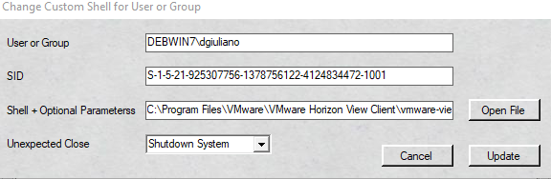

Click "OK".

It is that quick and easy to change the user shell.

Example Change Group Shell

To change a Group's shell highlight the row that you need to change.

Click the "Change Shell" button. You will see something similar as shown below:

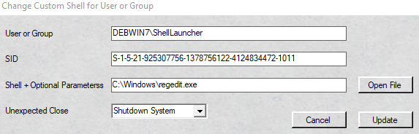

You can only change the shell's optional parameters and/or unexpected close.

In this example, we are changing both the shell path and unexpected close.

To change the path, just click the "Open File" button and browse to the new path you need to use.

In this example, the change will be to use the BosaNova Secure 5250 software for the group named ShellLauncher.

The next change will be the unexpected close.

Simply click on the drop down list box and change to the desired close.

In this example, when the 5250 client is closed we want the 5250 client to just restart automatically.

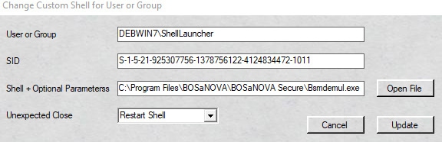

Click "OK".

It is a cinch to change the Group Shell using the 10ZiG UWF Wizard.

Example Delete User/Group Shell

To delete a User or Group shell just highlight the row that you need to change.

Click the "Delete Shell" button.

You will see something similar as shown below:

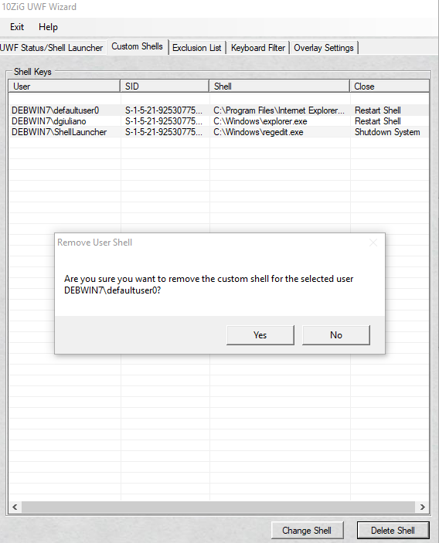

In the example above, we have chosen to delete the user shell for "defaultuser0".

Just click the "Yes" button for confirmation of the removal.

It is that straightforward.
Exclusion List

This tab allows you to define file, directory, registry exclusions plus enable UWF servicing.

Some services and features write information to a device's persistent volume, and expect that information to be present across device restarts.
You may need to configure your write filter to allow for specific file/directory/registry exclusions in order for these services and features to work correctly.

You can add specific files/folders/registry exclusions on a protected volume to an exclusion list to exclude those from being filtered by UWF.
When a file/folder/registry is in the exclusion list for a volume, all writes to those exclusions bypass UWF filtering, and are written directly to the protected volume and persist after the device restarts.

You cannot rename or move a file/folder from a protected location to an unprotected location, or vice versa. When write filters are active and you attempt to delete an excluded file/folder in Windows Explorer, the system attempts to move the file or folder to the Recycle Bin. This causes an error, because you cannot move files that are not filtered to a location that is write filter protected.

To work around this, you can disable the Recycle Bin. Alternatively, the user can press Ctrl+Shift and then left-click on the file to directly delete the excluded file, bypassing the Recycle Bin, or the user can delete the excluded file directly from a command prompt. You must restart the device for new exclusions to take effect.

You can add specific registry keys to an exclusion list to exclude those keys from being filtered by UWF. When a registry key is in the exclusion list, all writes to that registry key bypass UWF filtering and are written directly to the registry and persist after the device restarts.

UWF automatically excludes certain registry keys from being filtered.
These registry keys are primarily related to UWF configuration settings and cannot be removed from the exclusion list.

You must use an administrative account to add or remove registry/file/folder exclusions, and you must restart the device for new exclusions to take effect.

When a device is protected with UWF, you must use UWF servicing mode commands to service the device and apply updates to an image.
You can use UWF servicing mode to apply Windows updates, antimalware signature file updates, custom software and/or third-party software updates.

There are no predefined exclusions made in the thin client image; you will need to configure your own. Not to worry it is a breeze to configure them. There is a helpful link on the tab that you can review with suggested file and registry exclusions provided by 10ZiG.

Microsoft Windows 10 Enterprise 2016 LTSB has an issue installing windows updates because of being out for awhile and the size of their culmative updates. The two error messages associated with this is 0x8024000E and 0x8024000F. Microsoft has backed the number of SQL queries it sends to the device but in some cases you have to enable the page file to get passed the error message. The error has to do with the connection to the Microsoft server and not installing the updates itself. You can install the updates manually or create TZU packages that will push out via the 10ZiG manager.

However, if this is not an option there is the ability to turn on page file and its current status is displayed in real time. It is very important that you turn off page file after the windows updates are applied. As it reduces the life expectancy of the DOM. The UWF Wizard will warn you when page file is on and explain the life expectancy issue with it on. You can also call into technical support and obtain a new image that is current with all the updates.

Next is a snapshot of the tab. We will break each section down for a better understanding.

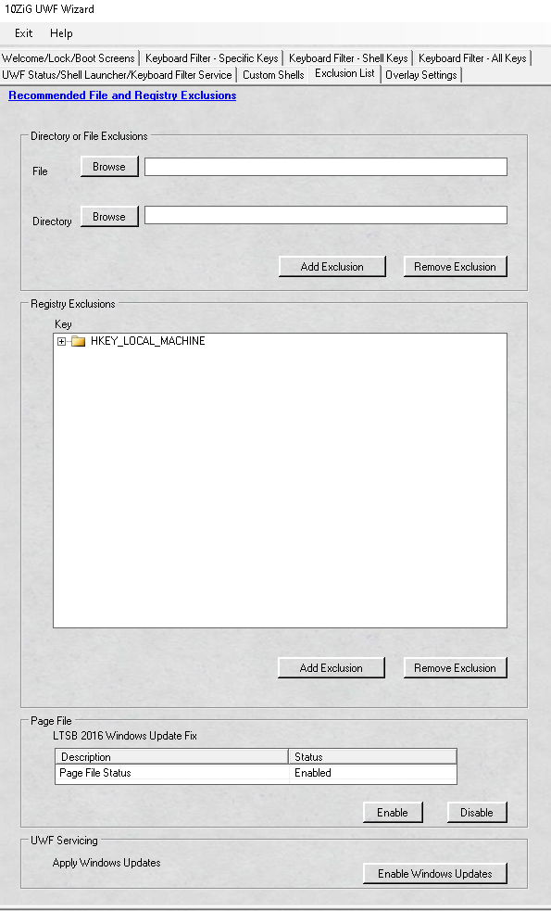

Recommended File/Registry Exclusions
Recommended File and Registry Exclusions

This is a hyper link that will direct you to a web page that has what 10ZiG Technology recommends for file/registry exclusions.

See link below:

Or go directly to

https://www.10zig.com/resources/support_faq/unified-write-filter

Directory or File Exclusions

Directory or File Exclusions
Directory or File Exclusions

Here is where you can browse to your file/directory exclusions.

File allows you to exclude a single file, whereas directory is the entire folder/sub directories/files underneath it if applicable.

You cannot add both the directory and file exclusion at the same time.

They must be done separately.

The file/directory must already exist on the system for the addition or removal of the exclusion

Remember the thin client must be restarted for the change to take effect.

Below is a snap shot of the section we are referring to.

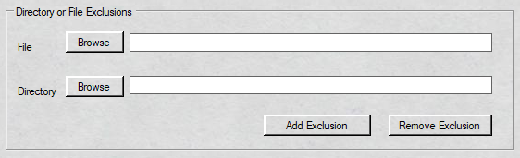

File Exclusions

This is a read only field and you must "Browse" to the path where the file resides.

The file must exist on the system.

Simply click the browse button, then select the file you need to exclude/remove.

Then click the appropriate command button.

A snap shot is provided below:

Example Adding/Removing File Exclusion

Adding/Removing file exclusions is a snap.

In the example below, we are saving a "keys.txt" file located in the user "dgiuliano’s" desktop.

If we wanted to add this exclusion you would just click the “Add Exclusion” button.

If you wanted to remove that exclusion you would just simply click the “Remove Exclusion” button.

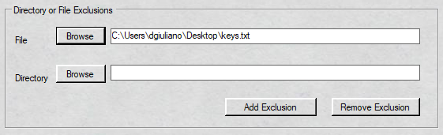

Directory Exclusions

This is a read only field and you must "Browse" to the path where the folder resides.

The directory must exist on the system.

Please note that choosing a directory will also include its subdirectories if applicable.

A snap shot is provided below:

Example Adding/Removing Directory Exclusion

Simply click the "Browse" button and select the directory you need to exclude/remove.

Then click the appropriate command button.

Please note that choosing a directory will also include its subdirectories if applicable.

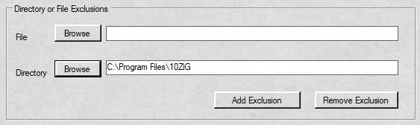

In the above example, we are adding an exclusion for a directory called "10ZiG" located in Program Files directory.

If we wanted to add this exclusion you would click the "Add Exclusion" button.

However, if you wanted to remove that exclusion click the "Remove Exclusion" button.

Registry Exclusions
Registry Exclusions

Here you can browse to the LOCAL MACHINE hive or value to select the exclusion but only while UWF is not enabled.

The registry hive or value must already exist on the system.

Remember you must restart the system for the change to take effect.

You can only exclude from the LOCAL MACHINE hive all other hives are not permitted.

See below for screen shot.

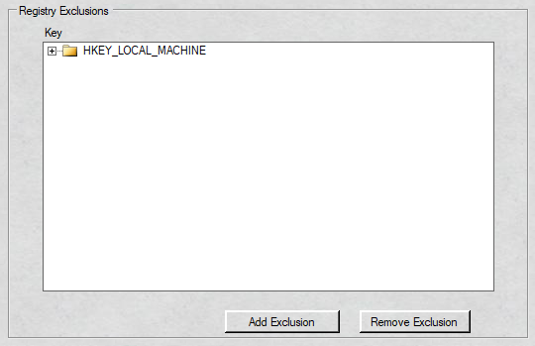

Please also note when UWF is enabled, you can no longer "Browse" to the registry hive however, you can still add a registry exclusion but you must type out the full path instead of using the "Browse" function.

See sample below when UWF is enabled:

Example of adding/removing registry exclusion

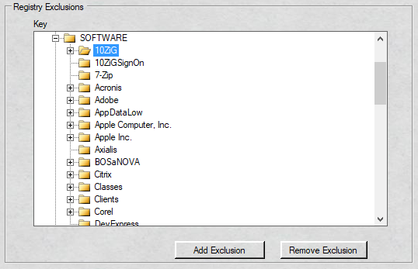

In the above example, the "10ZiG" hive is selected and if you click the "Add Exclusion" button this will allow this hive to persist changes.

However, if you wanted to remove this exclusion you can click the "Remove Exclusion" button instead.

It does not matter whether UWF is enabled or disabled you must reboot for the addition or removal of the registry exclusion to take effect.

Example adding/removing registry exclusion when UWF is enabled

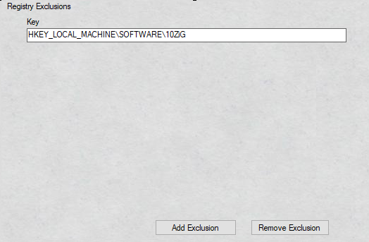

The example above does the same as the previous example where the "10ZiG" hive can be added/removed as a registry exclusion but UWF is enabled.

You need to type the LOCAL_MACHINE hive full path out in the text box.

Then click the appropriate command button for the desired result of adding/ removing a registry exclusion.

It does not matter whether UWF is enabled or disabled you must reboot for the addition or removal the registry exclusion to take effect.

Page File
Page File

Page file in Windows 10 is a hidden system file with the .SYS extension that is stored on your computer’s system drive (usually C:\).
The Page file allows the computer to perform smoothly by reducing the workload of the physical memory, or RAM.
Simply put, every time you open more applications than the RAM on your PC can accommodate, the programs already present in the RAM are automatically transferred to the Page file.
This process is technically called Paging. Because the Page file works as a secondary RAM, many times it is also referred to as Virtual Memory.
The minimum and maximum size of the Page file can be up to 1.5 times and 4 times of the physical memory that your computer has, respectively.

For example, if your computer has 1GB of RAM, the minimum Page file size can be 1.5GB, and the maximum size of the file can be 4GB.
On your thin client image the page file is disabled.
It has to be disabled as it will reduce the life expectancy of the Disk On Module (DOM).
The thin client does not come with a hard drive so the page file must be disabled.
Below is the section we are referring to.
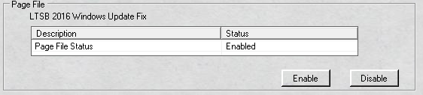

Windows 10 Enterprise 2016 LTSB

Microsoft Windows 10 Enterprise 2016 LTSB has an issue installing windows updates because of being out for awhile and the size of their culmative updates.
The two error messages associated with this is 0x8024000E and 0x8024000F.

Microsoft has backed the number of SQL queries it sends to the device but in some cases you have to enable the page file to get passed the error message.
The error has to do with the connection to the Microsoft server and not installing the updates itself.
You can install the updates manually or create TZU packages that will push out via the 10ZiG manager.

However, if this is not an option there is the ability to turn on page file and its current status is displayed in real time.
It is very important that you turn off page file after the windows updates are applied as it reduces the life expectancy of the DOM.
The UWF Wizard will warn you when page file is on and explain the life expectancy issue with it on.
You can also call into technical support and obtain a new image that is current with all the updates.

Below is the section being referenced:

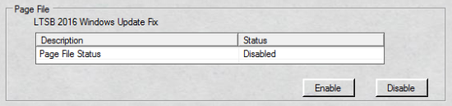

When page file is enabled the UWF Wizard will display an error message telling you to disable it because it diminishes the life expectancy of the Disk On Module (DOM).

Page File Enable

Microsoft Windows 10 Enterprise 2016 LTSB has an issue installing windows updates because of being out for awhile and the size of their culmative updates.
The two error messages associated with this is 0x8024000E and 0x8024000F.

Microsoft has backed the number of SQL queries it sends to the device but in some cases you have to enable the page file to get passed the error message.
The error has to do with the connection to the Microsoft server and not installing the updates itself.
You can install the updates manually or create TZU packages that will push out via the 10ZiG manager.

However, if this is not an option there is the ability to turn on page file and its current status is displayed in real time.
It is very important that you turn off page file after the windows updates are applied as it reduces the life expectancy of the DOM.
The UWF Wizard will warn you when page file is on and explain the life expectancy issue with it on.
You can also call into technical support and obtain a new image that is current with all the updates.

Below is the section being referenced:

You will notice the status of page file is disabled and this is the default on all our thin client images.

With the section referenced above you can enable page file to assist with installing your windows updates.

Example Page File Enable

To enable page file in Windows to assist with installing updates, please click on ther "Page File Status" line to highlight it and then click the button "Enable".

Shown below:

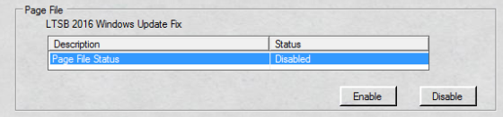

After page file is enabled it will tell you that you must be reboot to complete the process.

It will also display a warning that rnabling page file will reduce the life expectancy of the Disk On Module (DOM).

After answering the questions, you will see the page file status changes in real time.

See below:

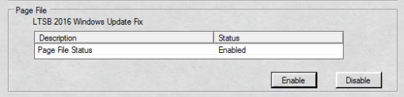

Remember you must reboot for the page file change to take effect.

Example Page File Enable Error Message

After you enable page file and reboot the operating system you will see an error message every time you reboot while page file is enabled.

See below:

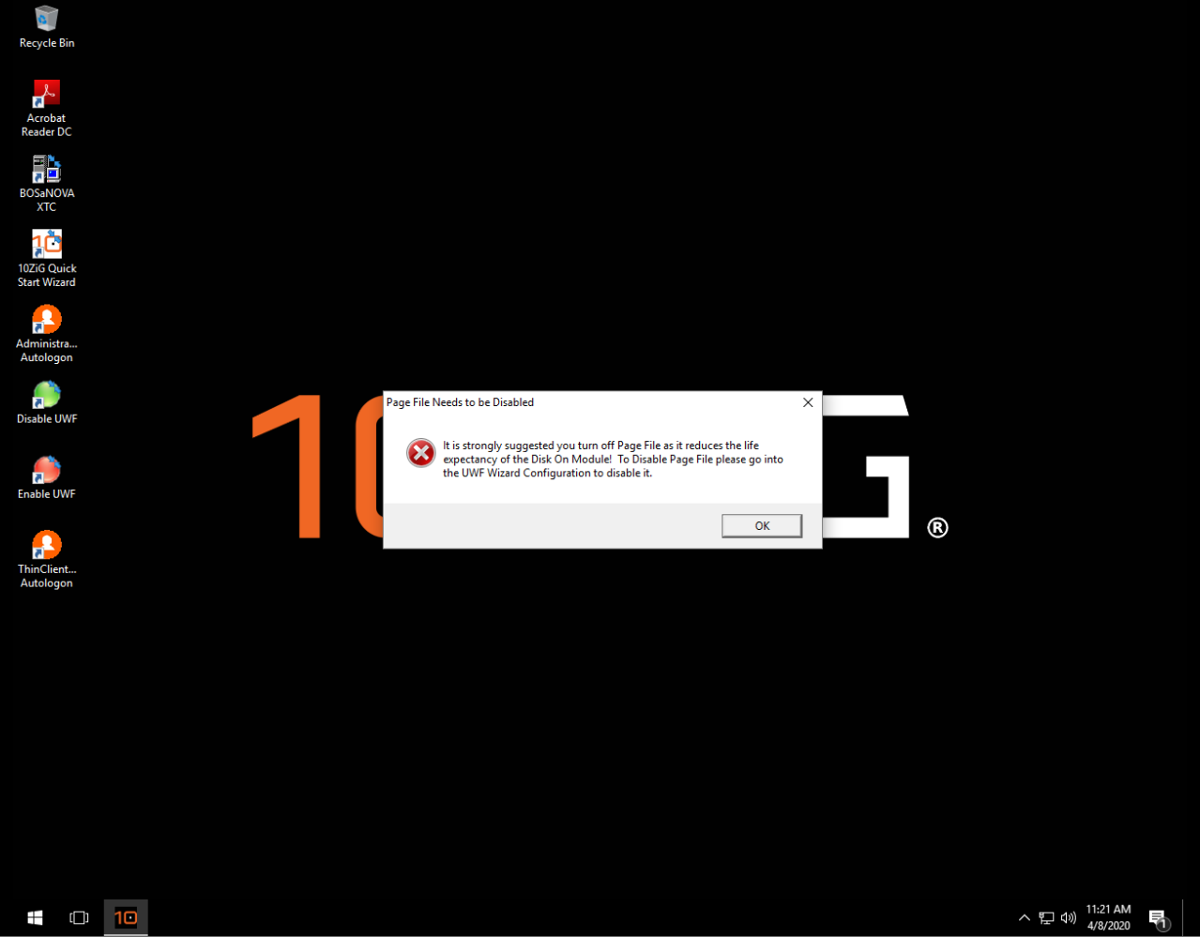

This message is to remind you that page file needs to be disabled.

If left on it diminishes the life expectancy of the Disk On Module (DOM).

After windows updates are done installing, please ensure to turn page file off.

Page File Disable

Microsoft Windows 10 Enterprise 2016 LTSB has an issue installing windows updates because of being out for awhile and the size of their culmative updates.
The two error messages associated with this is 0x8024000E and 0x8024000F.

Microsoft has backed the number of SQL queries it sends to the device but in some cases you have to enable the page file to get passed the error message.
The error has to do with the connection to the Microsoft server and not installing the updates itself.
You can install the updates manually or create TZU packages that will push out via the 10ZiG manager.

However, if this is not an option there is the ability to turn on page file and its current status is displayed in real time.
It is very important that you turn off page file after the windows updates are applied as it reduces the life expectancy of the DOM.
The UWF Wizard will warn you when page file is on and explain the life expectancy issue with it on.
You can also call into technical support and obtain a new image that is current with all the updates.

Below is the section being referenced:

You will notice the status of page file is enabled and this is NOT the default on all our thin client images.

Please ensure when windows updates are done installing you disable page file.

Example Page File Disable

To disable page file in Windows, please click on ther "Page File Status" line to highlight it and then click the button "Enable".

Shown below:

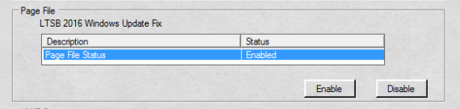

After page file is disabled it will tell you that you must be reboot to complete the process.

After answering the questions, you will see the page file status changes in real time.

See below:

Remember you must reboot for the page file change to take effect.

It is very important that you turn off page file after the windows updates are applied and reboot as it reduces the life expectancy of the DOM.

UWF Servicing
UWF Servicing

The UWF Servicing allows you to obtain Windows Updates easily with a click of a button.

It does not matter if UWF is enabled/disabled.
Just click the command button to enable.
Once enabled the thin client will automatically reboot and disable UWF.
It creates a new Windows User account and behind the scenes launches Windows Update transparently to the user.

The thin client will be left at the "UWF" Account login and will download and install however many updates that are available.

When complete the UWF Servicing mode will re-enable UWF and if auto logon is set, it will log the user back in with all the updates applied. If there is a failure on installing any of the updates UWF will still re-enable and leave logs in the event viewer.

Below is a snap shot of the UWF servicing mode.

Overlay Settings
Overlay Settings

The Unified Write Filter (UWF) protects the contents of a volume by redirecting all write operations on that volume to the overlay, which is a virtual representation of the changes to the volume.
Conceptually, an overlay is similar to a transparency overlay on an overhead projector.
Any change that is made to the transparency overlay affects the projected picture as it is seen by the viewer.
However, if the transparency overlay is removed, the underlying picture remains unchanged.
In a UWF protected system, UWF creates a single overlay, which contains information about writes to all protected volumes on a system.
The overlay supports up to 16 terabytes of protected volumes.
Below is a snapshot of the Overlay Settings tab.
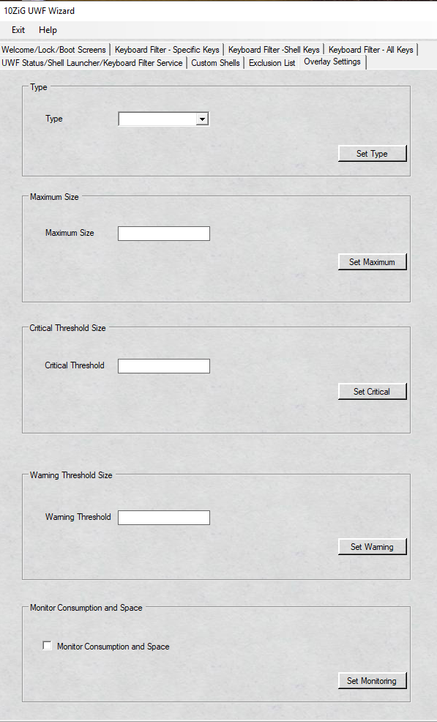

Before we go into each section, we want to briefly go over some details that will be beneficial and informational .
This will enable you to understand and better guide you in changing the overlay settings.
  - Overlay Storage
  - Overlay Thresholds and Notifications
  - Overlay Exhaustion
If you want to get right to the parameters:
  - Overlay Type
    - Example Overlay Type
  - Maximum Size for Overlay
    - Example Maximum Size for Overlay
  - Critical Threshold Size
    - Example Critical Threshold Size
  - Warning Threshold Size
    - Example Warning Threshold Size
  - Monitor Consumption and Space
    - Example Setting Monitor and Consumption Space

Overlay storage
Overlay storage

You can configure UWF to store the overlay either entirely in RAM (RAM-based), or to store the overlay in a pre-allocated file on the system volume (Disk-based).
All information in the overlay is lost after a device restarts or experiences a power loss, regardless of how the overlay is stored.
The overlay is created the first time the file system mounts a volume.
Each time that UWF redirects a write attempt to the overlay, the disk sectors that would be modified are copied to the overlay.
Because file systems do not access individual sectors on a volume, but rather clusters of sectors, the entire cluster that would be modified is copied to the overlay.
When the file system erases or deletes files that do not exist on the protected volume, UWF removes unneeded clusters from the overlay and returns the freed resources to the available pool.
This primarily affects the overlay size when temporary files are created and then deleted.

RAM-based overlay

In a RAM-based overlay, all overlay information is kept in system memory.
Because RAM-based overlays reduce access to the physical volume, they can reduce wear on write-sensitive media.
RAM-based overlays can be used with read-only media.
As applications continue to write to protected volumes, a RAM-based overlay consumes available free RAM until the overlay reaches a specified maximum size or reaches critically low levels of available RAM, which requires that the system be restarted.
Because RAM is typically much more expensive than disk space, available RAM usually limits how long your system can operate before needing to be restarted.
Please note when you use a RAM-based overlay, make sure to leave enough available RAM to meet at least the minimum required RAM for the system to run.
For example, if your OS requires at least 2 GB of RAM, and your device has 4 GB of RAM, set the maximum size of the overlay to 2 GB or less.
For the overlay type to take effect it does require a reboot.

Disk-based overlay

In a disk-based overlay, UWF uses a pre-allocated file created on the system volume to increase the available space for the overlay.
The maximum size of the overlay is limited to the size of the disk file.
The disk file does not dynamically grow in size, but must be pre-allocated on the volume.
Disk-based overlays require a Maximum Overlay Size of at least 1024 MB.
For the overlay type to take effect it does require a reboot.

Overlay thresholds and notifications
Overlay thresholds and notifications

Because overlays grow in size and consume available resources as applications continue to write to protected volumes, you may want to have your device notify the user when available resources are critically low.
You can configure UWF to write an event to the error log when the size of the overlay reaches or exceeds a configurable value. UWF uses Event Tracing for Windows (ETW) to write the event message.
You can configure a warning threshold level and a critical threshold level for the overlay size in UWF.
The warning threshold value must be lower than the critical threshold value.
When the size of the overlay exceeds these values, UWF writes an event.
If the overlay size is reduced to below the threshold levels, possibly from deleting temporary files, UWF writes an event to indicate that the overlay size has returned to a normal operating size.
Please note the warning and critical thresholds are triggered when the overlay size increases to meet the threshold values, and are not based on the amount of available resources remaining.

Overlay exhaustion
Overlay Exhaustion

If the size of the overlay is close to or equal to the maximum overlay size, any write attempts will fail, returning an error indicating that there is not enough space to complete the operation.
If the overlay on your device reaches this state, your device may become unresponsive and sluggish, and you may need to restart your device.
When Windows shuts down, it attempts to write a number of files to the disk.
If the overlay is full, these write attempts fail, causing Windows to attempt to rewrite the files repeatedly until UWF can determine that the device is trying to shut down and resolve the issue.
Attempting to shut down by using normal methods when the overlay is full or near to full can result in the device taking a long time, in some cases up to an hour or longer, to shut down.
You can often avoid this issue by using UWF to initiate the shut down or restart.
You can do this by using the following methods:
- Use the shutdown command with uwfmgr.exe.
- Use the restart command with uwfmgr.exe

To try and trouble shoot overlay exhaustion, review the section Monitor Consumption and Available Space. Then set Monitor Consumption and Available Space.

Overlay Type
Overlay Type

Now let us get into each section of the Overlay tab settings.
As stated previously there are two types of overlays RAM and Disk based.
By default the thin client image is set to RAM based.
See the section located below:

Example of Changing Overlay Type

The 10ZiG UWF Wizard makes changing the type painless!

Just click on the drop down combo box and make the desired selection and click the set type command button.
There are two options only:
  - RAM-Based
  - Disk-Based
Maximum Size Overlay

Maximum Size for Overlay
Maximum Size for Overlay

The Maximum Size for the overlay can be set here and it does not take effect until the thin client is rebooted.
The size is in megabytes.
The default size set in the thin client image is 1024 MB.
Be careful to not set the maximum cache size of the overlay past what is available.
If maximum size overlay is changed a reboot is required for the change to take effect.
See section below:

Example Setting Maximum Size

The example above sets the maximum size of the overlay to 2048 megabytes.
It is a cinch with the 10ZiG UWF Wizard to set the maximum size.
Just type in the amount in megabytes and click the set maximum command button.
If maximum size overlay is changed a reboot is required for the change to take effect.

Critical Threshold Size
Critical Threshold Size

The unified write filter sends a critical threshold notification event when the unified write filter overlay size reaches or exceeds this value.

The critical threshold size is set in megabytes.

The default size in the thin client image is 1024 megabytes.

If critical threshold size is changed a reboot is required for the change to take effect.

Below is the section:

Example Setting Critical Threshold Size

The example above sets the critical threshold size of the overlay to 2048 megabytes.
It is a snap with the 10ZiG UWF Wizard to set the critical threshold size.
Just type in the amount in megabytes and click the set critical command button.
If critical threshold size is changed a reboot is required for the change to take effect.

Warning Threshold Size
Warning Threshold Size

The unified write filter sends a warning threshold notification event when the unified write filter overlay size reaches or exceeds this value.
The warning threshold size is set in megabytes.
The default size in the thin client image is 512 megabytes.
If the warning threshold size is changed a reboot is required for it to take effect.

See section below:

Example Setting Warning Threshold Size

The example above sets the warning threshold size of the overlay to 1024 megabytes.
It is a quite simple with the 10ZiG UWF Wizard to set the warning threshold size.
Just type in the amount in megabytes and click the set warning command button.
If the warning threshold size is changed a reboot is required for it to take effect.

Monitor Consumption and Space
Monitor Consumption and Space

This section is designed to assist you trouble shoot if you are trying to determine if you have overlay exhaustion.
The tool is designed to check the overlay consumption use and available space over and over.
You must close the window if you want to end it.
See section below:

Example setting Monitor Consumption and Available Space

The example above runs the diagnostic tool to check overlay consumption and overlay space.
It is a quite easy with the 10ZiG UWF Wizard to set the tool up.
Just click the Monitor Consumption and Space checkbox and then click the Set Monitoring button.
Please note UWF must be enabled for the tool to show the overlay consumption and available space.
A Command prompt will run over and over displaying the overlay consumption in megabytes as well as the available space.
See sample below:
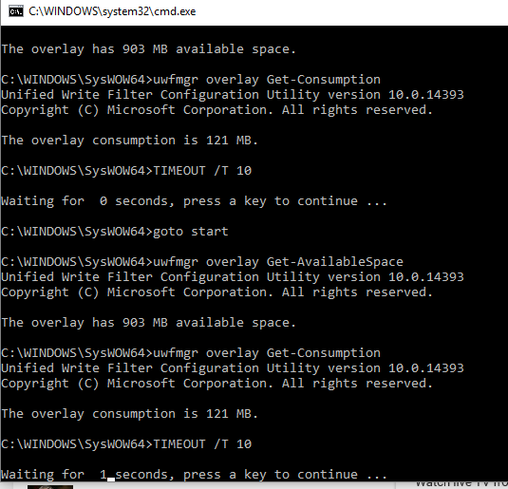

Welcome/Lock/Boot Screen
Welcome, Autologon, Lock, UI Verbosity, UI Elements and Boot Screens

This section contains Welcome, Autologon, Lock, UI Verbosity, UI Elements and Boot screens that can be customized through the 10ZiG UWF Wizard.
You can use the 10ZiG UWF Wizard to suppress Windows UI elements that relate to the Welcome, Shutdown, Lock, and Boot screens.
For example, you can suppress all elements of the Welcome screen UI.
You can also suppress the blocked shutdown resolver (BSDR) screen and automatically end applications while the OS waits for apps to close before a shutdown.
You can remove several elements to brand the image neutral.
In this section, you can suppress certain Windows elements to experience a custom logon.
Each section tells you the current status on whether it is enabled or disabled as shown below:
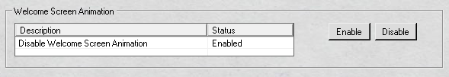
In the example above, the current status of the Disable Windows Screen animation is turned on.
That means that the Windows Animation will not be shown. The Windows Animation that is being referred to here is on "New User Login".
Screen referenced below:
When you change the status of an item it is reflected in real-time and will require a reboot to see the changes made.
A screen shot is shown below of the section referenced:
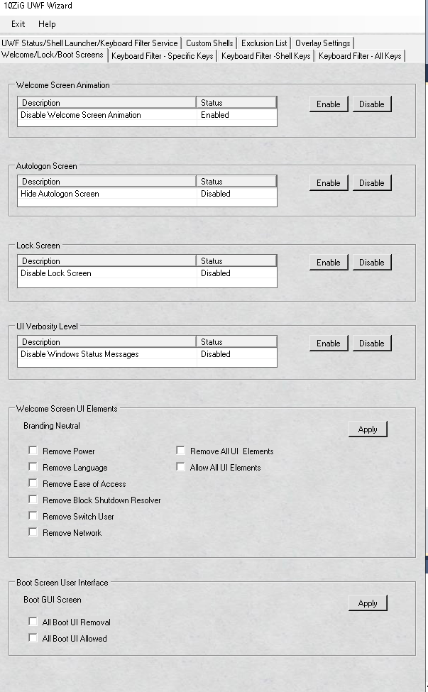

Disable Welcome Screen Animation
Disable Windows Screen Animation

Disables the animation screen displayed during a new Windows logon.

The annoying Hi, I'm organizing your files just like the last 3-4 times you've seen this after a new build is applied.
In the example above, the current status of the Disable Windows Screen animation is enabled.
That means that the Windows Animation will not be shown through the new account Windows Log On process.
This is the default on the image for Windows Animation not be displayed.
Here is a sample of the login we are referring to

Example Turning Off Windows Screen Animation

Disables the Welcome screen transition animation for new user logon.

The section to turn off Windows Animation is shown below:
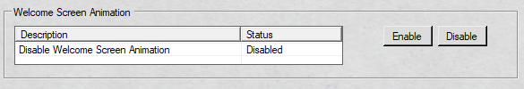
To turn off Windows Animation select the "Disable Welcome Screen Animation" and click the button "Enable".
You will receive an informational message that the Disable Welcome Screen Animation is now active.
Your status of the item will be updated in real-time as shown below:

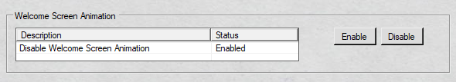

This is how you need to set this item if you want to "disable" the Welcome Screen Animation.

Example Turning On Windows Screen Animation

Enables the Welcome screen transition animation for new user logon.

The section to turn off Windows Animation is shown below:

To turn on Windows Animation select the "Disable Welcome Screen Animation" and click the button "Disable".
You will receive an informational message that the Disable Welcome Screen Animation is now inactive.
Your status of the item will be updated in real-time as shown below:

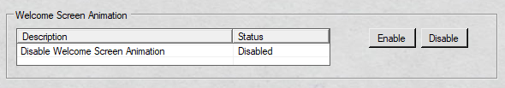

This is how you need to set this item if you want to "enable" the Welcome Screen Animation.

Autologon Screen
Autologon Screen
Hides the Welcome screen when automatic sign-in is enabled.
By default, Windows briefly shows the sign-in UI before switching to the user shell. You can disable this feature and have a generic logon launching directly into the shell without displaying the sign-in UI when automatic sign-in is enabled.
The screen shot is of the referenced object is shown below:
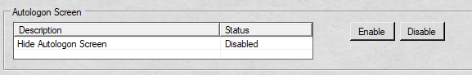
In the example above, the current status of the Hide Autologon Screen is disabled.
This means that the Windows will briefly show the automatic auto login through the log in process.
This is the default on the image for Autologon to be displayed.
Here is a sample screen referenced below that is displayed by default even with autologin enabled.:
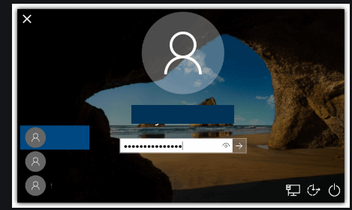

Example Hiding Autologon Screen
Hides the Welcome screen when automatic sign-in is enabled.
By default, Windows briefly shows the sign-in UI before switching to the user shell. You can disable this feature and have a generic logon launching directly into the shell without displaying the sign-in UI when automatic sign-in is enabled.

The section to Hide the Autologon Screen is shown below:
To turn off the Autologon Screen select the "Hide Autologon Screen" and click the button "Enable".
You will receive an informational message that the Hiding the Autologon Screen is now active.
Your status of the item will be updated in real-time as shown below:

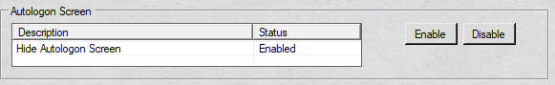

This is how you need to set this item if you want to "hide" the Autologon Screen.

How auto login would be displayed if set to autologon with this feature enabled.

Example Displaying Autologon Screen
Displays the Welcome screen when automatic sign-in is enabled.
By default, Windows briefly shows the sign-in UI before switching to the user shell. You can disable this feature and have a generic logon launching directly into the shell without displaying the sign-in UI when automatic sign-in is enabled.

The section to Hide the Autologon Screen is shown below:

To turn on or show the Autologon Screen select the "Hide Autologon Screen" and click the button "Disable".
You will receive an informational message that the Hiding the Autologon Screen is now inactive.
Your status of the item will be updated in real-time as shown below:

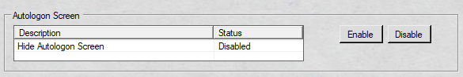

This is how you need to set this item if you want to "display" the Autologon Screen.

Sample screen that you would see when auto login is set shown below:

Lock Screen

Lock Screen
Lock Screen

Disables the lock screen functionality and UI elements.
By default, Windows shows the lock screen
The screen shot is of the referenced object is shown below:
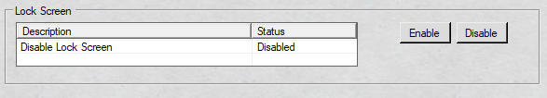
In the example above, the current status of the Hide Autologon Screen is disabled.
This means that the Windows will show the lock screen.
See referenced object shown below:
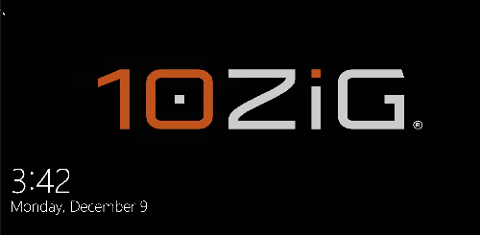
This is the default on the image for Lock Screen is to be displayed.

Example Hiding Lock Screen

Disables the lock screen functionality and user interface elements.
By default, Windows shows the lock screen
The screen shot is of the referenced object is shown below:
To hide the Lock Screen select the "Disable Lock Screen" and click the button "Enable".
You will receive an informational message that the Hiding the Lock Screen is now active.
Your status of the item will be updated in real-time as shown below:
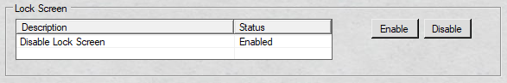
In the above example, the Lock Screen is now set to be not displayed.
When the workstation is locked it will show the log on screen for the logged in user.

Example Displaying Lock Screen

Displays the lock screen functionality and user interface elements.
By default, Windows shows the lock screen
The screen shot is of the referenced object is shown below:
To display the Lock Screen select the "Disable Lock Screen" and click the button "Disable".
You will receive an informational message that the Hiding the Lock Screen is now inactive.
Your status of the item will be updated in real-time as shown below:
In the above example, the Lock Screen is now set to be displayed.
Referenced object now being displayed shown below:

UI Verbosity Level
UI Verbosity Level

Disables the Windows status messages during device startup, sign-in, and shut down.
By default, Windows displays the UI Verbosity Level
The screen shot is of the referenced object is shown below:
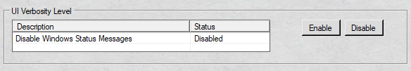
In the example above, the current status of the UI Verbosity Level is disabled.
This means that the Windows will show all the Windows Status messages on startup, sign-in and shutdown.
This is the default on the image for the UI Verbosity Level is to be displayed.
Some examples ofr windows status messages you might see.

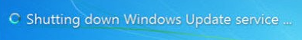

Example Hiding UI Verbosity Level

Disables the Windows status messages during device startup, sign-in, and shut down.
By default, Windows displays the UI Verbosity Level
The screen shot is of the referenced object is shown below:
In the example above, the current status of the UI Verbosity Level is being displayed.
To hide the UI Verbosity Level select the "Disable Windows Status Messages" and click the button "Enable".
You will receive an informational message that the UI Verbosity Level is now being disabled, so no messages will be displayed during startup, sign-in and shut down.
Your status of the item will be updated in real-time as shown below:
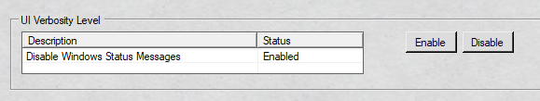
In the above example, the UI Verbosity Level is now set to be not displayed.
So messages like this for example will no longer be displayed

Example Displaying UI Verbosity Level

Enables the Windows status messages during device startup, sign-in, and shut down.
By default, Windows displays the UI Verbosity Level.
Here is some examples that you would expect to see with Verbosity level being displayed.
The screen shot is of the referenced object is shown below:
In the example above, the current status of the UI Verbosity Level is being not being displayed.
To display the UI Verbosity Level select the "Disable Windows Status Messages" and click the button "Disable".
You will receive an informational message that the UI Verbosity Level is now being displayed, so messages will be seen during startup, sign-in and shut down.
Your status of the item will be updated in real-time as shown below:
In the above example, the UI Verbosity Level is now set to be displayed.

Welcome Screen UI Elements
Welcome Screen UI Elements

Disables the Welcome Screen as well as all of its UI elements. You can also just remove some of the UI elements that are displayed on these screens.

An example of the Welcome Screen is shown below:

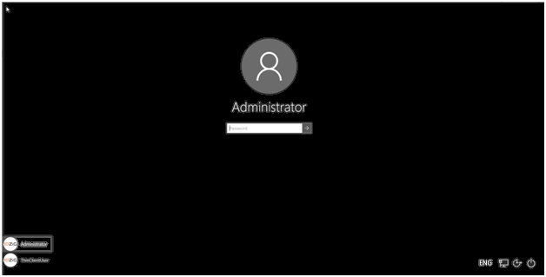

The section is where can disable the Logon and Lock screens is referenced below:

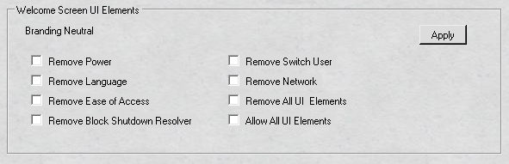
To remove on item(s), you simply select the desired check boxes and click the "Apply" button.
This is the default on the image is for the Welcome Screen to be displayed with all UI elements.
(Please note: Only when you have more than one language installed in the operating system will the language icon be displayed.)

Branding Neutral

Specifies which UI elements display on the Welcome screen.

An example of the Welcome is shown below:

The buttons below can be removed or all can be removed off of the Welcome Screen.

The "Power" icon referenced on the Welcome Screen is shown below:
Remove Power

The "Language" icon referenced on the Welcome Screen is shown below:
(Please note: Only when you have more than one language installed in the operating system will the language icon be displayed.)
Remove Language

The "Ease of Access" icon referenced on the Welcome Screen is shown below:
Remove Ease of Access

The "Block Shutdown Resolver" has no button but a screen that causes the operating system to immediately force close any applications that are blocking system shut down.

The referenced screen is shown below:

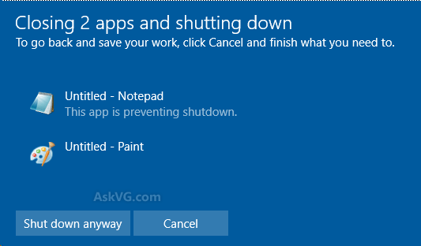

Remove Block Shutdown Resolver

The "Switch User" icon referenced on the Welcome Screen is shown below:
(Please note: Only when you have "Fast Switching" enabled will an icon be displayed. By default this is enabled on the thin client operating system.)
The "Switch User" icon referenced on the Welcome Screen is shown below:
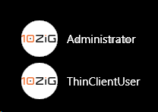
Remove Switch User

The "Network" icon referenced on the Welcome Screen is shown below:

Remove Network

The "Allow All UI Elements" icon shows all of the above icons on the Welcome Screen is shown below:
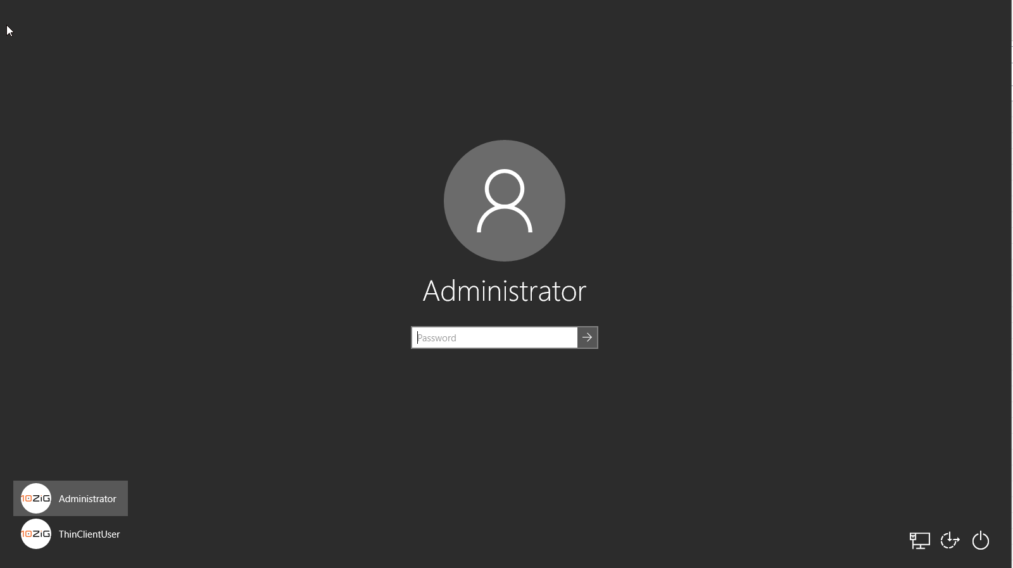
(Please note: Only when you have more than one language installed in the operating system will the language icon be displayed. Also, when you have "Fast Switching" enabled will an icon be displayed. By default this is enabled on the thin client operating system)
Allow All UI Elements

The "Remove All UI Elements" icon shows all of the above icons on the Welcome Screen is shown below:

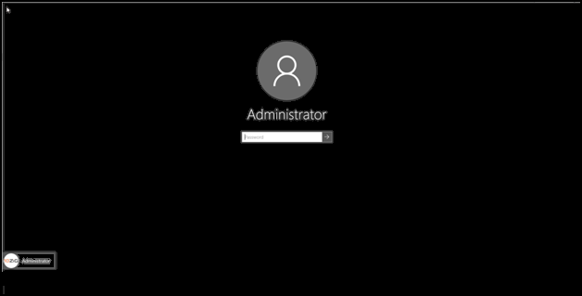

Remove Power
The "Power" icon referenced on the Welcome Screen is shown below:
You prevent this button from displaying.
Here is Welcome Screen shown below with all the UI Elements displayed

Once the "Power" button is removed it will look like the Welcome Screen below:
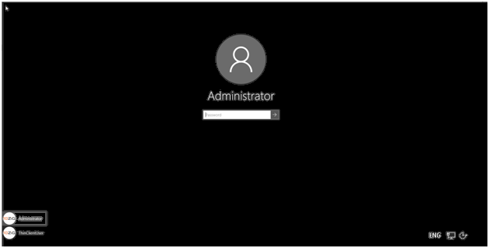

Example Removing Power Button

Removes the "Power" button from the Welcome Screen.
By default, the power button is displayed.
See referenced item shown below:
The referenced object to remove the button is shown below:

To remove the "Power" button from the Welcome Screen click the "Remove Power" check box as shown below and click the "Apply" button.
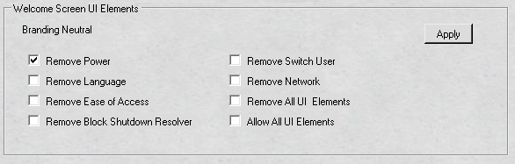
After a reboot your Welcome Screen should reflect the "Power" button being removed.
It should look something like this
Please note if you removed more than one item the screenshot will not reflect this and if you only have one language installed this button will not be shown either.

Remove Language

The "Language" icon referenced on the Welcome Screen is shown below:
(Please note: Only when you have more than one language installed in the operating system will the language icon be displayed.)
You prevent this button from displaying.
Here is Welcome Screen shown below with all the UI Elements displayed

Once the "Language" button is removed it will look like the Welcome Screen below:
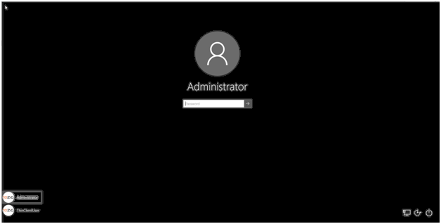

Example Removing Language Button

Removes the "Language" button from the Welcome Screen.
By default, the "Language" button is displayed.
See referenced screen below:
(Please note: Only when you have more than one language installed in the operating system will the language icon be displayed.)
The referenced object to remove the "Language" button is shown below:
To remove the "Language" button from the Welcome Screen click the "Remove Language" check box as shown below and click the "Apply" button.
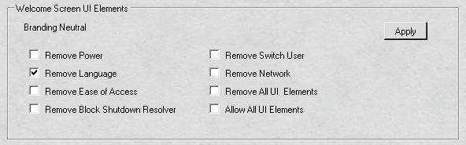
After a reboot your Welcome Screen should reflect the "Language" button being removed.
Please note if you removed more than one item the screenshot will not reflect this either.

Remove Ease of Access

The "Ease of Access" icon referenced on the Welcome Screen is shown below:
You prevent this button from displaying.
Here is Welcome Screen shown below with all the UI Elements displayed

Once the "Ease of Access" button is removed it will look like the Welcome Screen below:
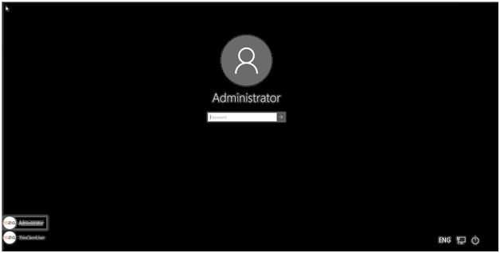

Example Removing Ease of Access Button

Removes the "Ease of Access" button from the Welcome Screen.
By default, the "Ease of Access" button is displayed.
Referenced screen shown below:
The referenced object to remove the "Ease of Access" button is shown below:
To remove the "Ease of Access" button from the Welcome Screen click the "Remove Ease of Access" check box as shown below and click the "Apply" button.
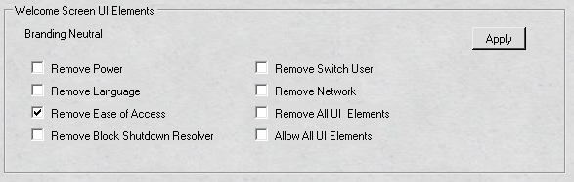
After a reboot your Welcome Screen should reflect the "Ease of Access" button being removed.
Please note if you removed more than one item the screenshot will not reflect this and if you only have one language installed this button will not be shown either.

Remove Block Shutdown Resolver

Disables the blocked shutdown resolver (BSDR) screen so that restarting or shutting down the system causes the operating system to immediately force close any applications that are blocking system shut down.

No UI is displayed and users are not given a chance to cancel the shutdown process.

This can result in a loss of data if any open applications have unsaved data.

The "Block Shutdown Resolver" has no button but a screen that causes the operating system to immediately force close any applications that are blocking system shut down.

The referenced screen is shown below:

Example Removing Block Shutdown Resolver

Disables the blocked shutdown resolver (BSDR) screen so that restarting or shutting down the system causes the operating system to immediately force close any applications that are blocking system shut down.

No UI is displayed and users are not given a chance to cancel the shutdown process.

This can result in a loss of data if any open applications have unsaved data.
By default, the "Block Shutdown Resolver" is displayed.
The referenced object to remove the "Block Shutdown Resolver" button is shown below:
To remove the "Block Shutdown Resolver" from the operating click the "Remove Block Shutdown Resolver" check box as shown below and click the "Apply" button.
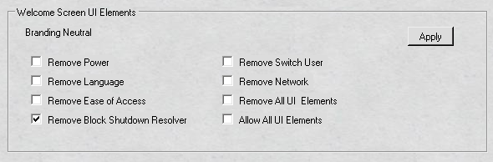
After a reboot or shutdown your image should not display any messages that ask if you want to cancel out of a shutdown or restart process.

Remove Switch User

The "Switch User" icon referenced on the Welcome Screen is shown below:
(Please note: Only when you have "Fast Switching" enabled will an icon be displayed. By default this is enabled on the thin client operating system. Also, you must have more than one user defined in the operating system)
The "Switch User" buttons referenced on the Welcome Screen is shown below:
Here is Welcome Screen shown below with all the UI Elements displayed.

Once the "Switch User" button is removed it will look like the Welcome Screen below:
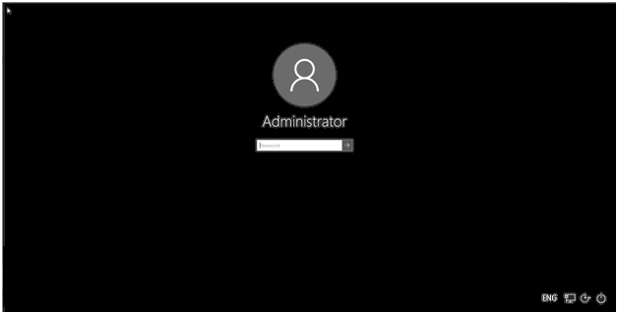

Example Removing Switch User Button

Removes the "Switch user" button from the Welcome Screen.
By default, the "Switch User" button is displayed.
The referenced object to remove the "Switch" button is shown below:
To remove the "Switch User" button from the Welcome Screen click the "Switch User" check box as shown below and click the "Apply" button.
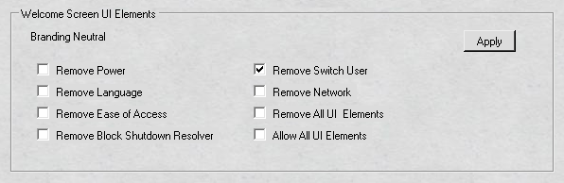
After a reboot your Welcome Screen should reflect the "Switch User" button being removed.
Please note if you removed more than one item the screenshot will not reflect this and if you only have one language installed this button will not be shown either.

Remove Network

The "Network" icon referenced on the Welcome Screen is shown below:
You prevent this button from displaying.
Here is Welcome Screen shown below with all the UI Elements displayed

Once the "Network" button is removed it will look like the Welcome Screen below:
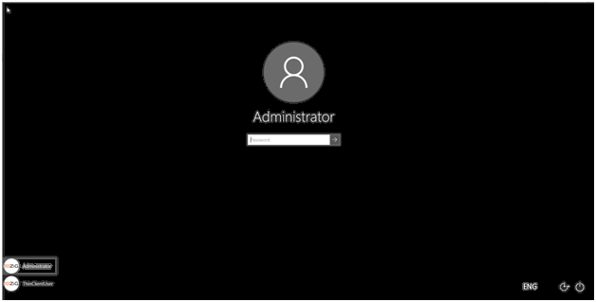

Example Removing Power Button

Removes the "Network" button from the Welcome Screen.
By default, the "Network" button is displayed.
See referenced item shown below:
The referenced object to remove the button is shown below:

To remove the "Network" button from the Welcome Screen click the "Remove Network" check box as shown below and click the "Apply" button.
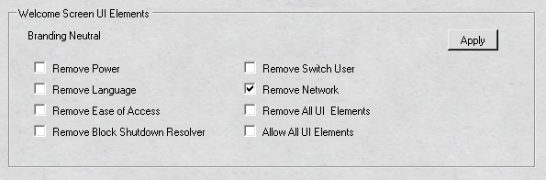
After a reboot your Welcome Screen should reflect the "Power" button being removed.
It should look something like this
Please note if you removed more than one item the screenshot will not reflect this and if you only have one language installed this button will not be shown either.

Allow All UI Elements

Allow all UI elements on the Welcome Screen and does include the "Blocked Shutdown Resolver".

This is the default for the thin client image.

An example of the "Welcome Screen" with all the UI elements is shown below:

The buttons described below on the Welcome Screen.

The "Power" icon referenced on the Welcome Screen is shown below:
Remove Power

The "Language" icon referenced on the Welcome Screen is shown below:
(Please note: Only when you have more than one language installed in the operating system will the language icon be displayed.)
Remove Language

The "Ease of Access" icon referenced on the Welcome Screen is shown below:
Remove Ease of Access

The "Block Shutdown Resolver" has no button but a screen that causes the operating system to immediately force close any applications that are blocking system shut down.

The referenced screen is shown below:

Remove Block Shutdown Resolver

The "Switch User" icon referenced on the Welcome Screen is shown below:
(Please note: Only when you have "Fast Switching" enabled will an icon be displayed. By default this is enabled on the thin client operating system.)
The "Switch User" icon referenced on the Welcome Screen is shown below:
Remove Switch User

The "Network" icon referenced on the Welcome Screen is shown below:

Remove Network

Example Allow All UI Elements

Allows all UI elements on the Welcome Screen and does include "Blocked Shutdown Resolver".

This is the default for the thin client image.
The referenced object to "Allow All UI Elements" is shown below:
To "Allow All UI Elements" for the image click the "Allow All UI Elements" check box as shown below and click the "Apply" button.
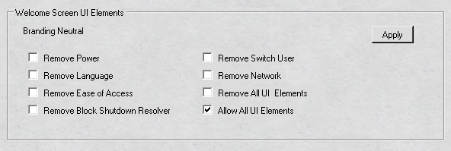
After a reboot your Welcome Screen should reflect "All UI Elements" and "Blocked Shutdown Resolver" shown below:
Please note if you removed more than one item the screenshot will not reflect this and if you only have one language installed this button will not be shown either.

Remove All UI Elements

Remove all UI elements on the Welcome Screen and does include "Blocked Shutdown Resolver".

The default for the thin client image is to allow all UI Elements.

An example of the "Welcome Screen" with all the UI elements is shown below:

Remove all UI Elements include the buttons below. If you only want to remove some of the UI Elements; go to the corresponding hyperlink for the element you wish to remove.

Below is an example of the "Welcome Screen" with all UI Elements removed.

The "Power" icon referenced on the Welcome Screen is shown below:
Remove Power

The "Language" icon referenced on the Welcome Screen is shown below:
(Please note: Only when you have more than one language installed in the operating system will the language icon be displayed.)
Remove Language

The "Ease of Access" icon referenced on the Welcome Screen is shown below:
Remove Ease of Access

The "Block Shutdown Resolver" has no button but a screen that causes the operating system to immediately force close any applications that are blocking system shut down.

The referenced screen is shown below:

Remove Block Shutdown Resolver

The "Switch User" icon referenced on the Welcome Screen is shown below:
(Please note: Only when you have "Fast Switching" enabled will an icon be displayed. By default this is enabled on the thin client operating system.)
The "Switch User" icon referenced on the Welcome Screen is shown below:
Remove Switch User

The "Network" icon referenced on the Welcome Screen is shown below:

Remove Network

Example Remove All UI Elements

Removes all UI elements on the Welcome Screen and does include "Blocked Shutdown Resolver".

This is not the default for the thin client image.
The referenced object to "Remove All UI Elements" is shown below:
To "Remove All UI Elements" for the image click the "Remove All UI Elements" check box as shown below and click the "Apply" button.
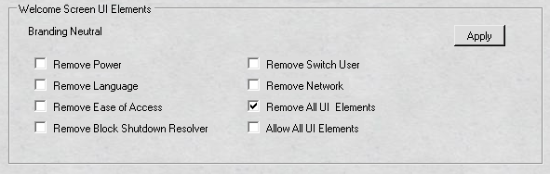
After a reboot your Welcome Screen should "RemoveUI Elements" and "Blocked Shutdown Resolver", sample screen shown below:

Boot Screen User Interface
Boot Screen User Interface

When Windows boots up it displays a graphical user interface (GUI).

See below:

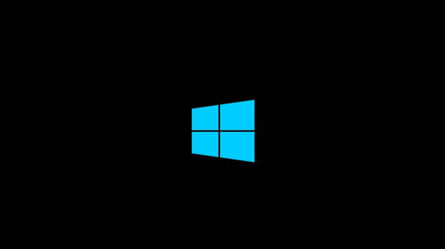

The section is where can enable or disable the Boot Screen GUI.

It is referenced below:

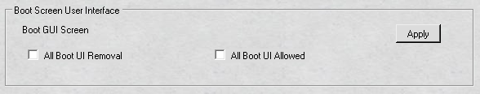

Boot GUI Screen

Windows boot graphical user interface (GUI) is a computer environment that simplifies the user's interaction with the computer by booting up the operating system usually with no interaction required.

Below is the (GUI) for Windows 10 2019 LTSC booting up:

Since KIOSK's are becoming quite popular these days, you have the option here to suppress the boot up process.

This option will suppress all OS elements that appear when the device starts or resumes, crash screens etc...

All Boot UI Removal

This option will suppress all OS elements that appear when the device starts or resumes, crash screens etc...

Below is one example of a UI element that occurs during the boot up process

By default this all boot up UI elements enabled on the thin client image.

If you want this disabled then you need to remove all UI elements from the boot up process.

After you disable it and reboot, the Windows boot up process should look like this

Below is a snap shot of where you can do this.

Example All Boot UI Removal

This hides the Windows boot up process.

By default the thin client image shows the Windows boot up process.
The referenced object to hide/allow the Windows boot up process is shown below:

To hide the Windows boot up process tick the "All Boot UI Removal" check box and click the "Apply" button.
See below:
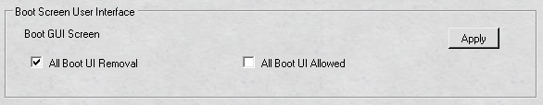
After a reboot Windows boot up GUI will not be shown.
See screen shot below to see what boot up process should look like.

All Boot UI Allowed

This option will allow all OS elements that appear when the device starts or resumes, crash screens etc...

Below is one example of a UI element that is suppressed during the boot up process

By default this option of allowing all the UI elements to be displayed is default on the thin client image.

If you have previously disabled then you will want to re-enable the GUI, otherwise you need to not change the option.

After you allow all UI elements and reboot, the Windows boot up process should look like this:

Below is a snap shot of where you can do this.

Example All Boot UI Allowed

This allows the Windows boot up GUI elements to be displayed.

By default the thin client image shows the Windows boot up GUI process.
The referenced object to hide/allow the Windows boot up process is shown below:

To allow the Windows boot up process tick the "All Boot UI Allowed" check box and click the "Apply" button.
See below:
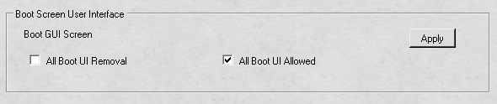
After a reboot Windows boot up GUI will be displayed.
See screen shot below to see what boot up process should look like.

Keyboard Filter
Keyboard Filter

This section introduces and takes use of the keyboard filter in Windows IoT Enterprise LTSB/LTSC.
You can customize your device for the full KIOSK experience eliminating key press or combinations.
You can use the Keyboard Filter to suppress undesirable key presses or key combinations.
Normally, a customer can use certain Microsoft Windows key combinations like Ctrl+Alt+Delete or Ctrl+Shift+Tab to alter the operation of a device by locking the screen or using Task Manager to close a running application.
This may not be desirable if your device is intended for a dedicated purpose.
The Keyboard Filter feature works with physical keyboards, the Windows on-screen keyboard and the touch keyboard.
The keyboard filter also detects dynamic layout changes, such as switching from one language set to another, and continues to suppress keys correctly, even if the location of suppressed keys has changed on the keyboard layout.
Keyboard Filter has the following features:

- Supports hardware keyboards, the standard Windows on-screen keyboard, and the touch keyboard (TabTip.exe).
- Suppresses key combinations even when they come from multiple keyboards.
For example, if a user presses the Ctrl key and the Alt key on a hardware keyboard, while at the same time pressing Delete on a software keyboard, Keyboard Filter can still detect and suppress the Ctrl+Alt+Delete functionality.
- Supports numeric keypads and keys designed to access media player and browser functionality.
- Automatically handles dynamic layout changes.
- Can be enabled or disabled for administrator accounts.
- Can force disabling of Ease of Access functionality.
- Can block physical hardware keys.
- Supports x86 and x64 architectures.
- If Sticky Keys are enabled, a user can bypass keyboard filter in certain situations. You can configure the keyboard filter to disable all ease of access features and prevent users from enabling them.

You can enable ease of access features for administrator accounts, while still disabling them for standard user accounts, by making sure that keyboard filter is disabled for administrator accounts.
Starting a device in Safe Mode bypasses keyboard filter.
The Keyboard Filter service is not loaded in Safe Mode, and keys are not blocked in Safe Mode.
Keyboard filter cannot block the Sleep key.
Some custom keyboard software, such as Microsoft IntelliType Pro, can install Keyboard Filter drivers that prevent Keyboard Filter from being able to block some or all keys, typically extended keys like Browser Home and Search.
By default, ease of access features is enabled and keyboard filter is disabled for administrator accounts.
Not to worry though the keyboard filter can be disabled only for the administrator group.

You can block the following type keys.

  - Accessibility Keys
  - Application Keys
  - Browser Keys
  - Modifier Keys
  - Security Keys
  - Shell Keys
  - Administrator Enable/Disable Keyboard Filter
  - Accessibility Enable/Disable

Please Note the keyboard filter is not supported in a remote desktop session only localization on the thin client OS.
The Keyboard Filter is broken into 3 tabs and it will display the real time status of the key(s) you want to enable or disable
  - Keyboard Filter - Specific Keys
  - Keyboard Filter - Shell Keys
  - Keyboard Filter - All Keys
Below is a snap shot of the keyboard filter section.
We will go through each section accordingly.

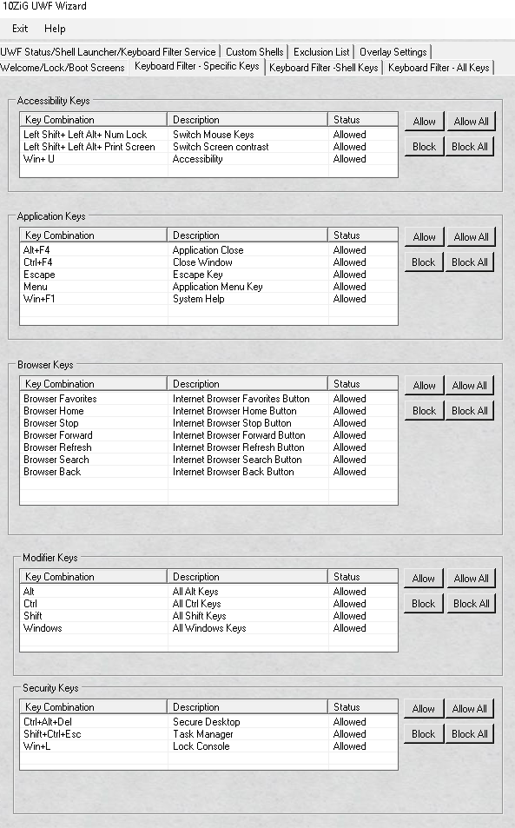

Keyboard Filter - Specific Keys
Keyboard Filter - Specific Keys

The "Keyboard Filter - Specific Keys" tab allows you to allow, block, allow all or block all keys board shortcuts in Accessibility, Application, Browser, Modifier and Security.

When the configuration form is accessed the current status is displayed in real time.

You do not need to reboot to see the key combination blocked

It is blocked immediately with no reboot.

Below is a screen shot of the "Keyboard Filter - Specific Keys" tab.

Accessibility Keys
Accessibility Keys

These common keys or key combinations display accessibility functions.
By default the key combinations here are the common ones.
Since these may not be well know we will explain what they do.
  - Left Shift + Left Alt + NumLock – Turns on/off mouse keys
  - Left Shift + Left Alt + Print Screen – Toggles on/off High Contrast Mode
  - Win + U – Turns on Utility Manager
By default these are enabled on the image in the thin client unless you disable all of accessibility.
If you want to block these key combinations or block all of them see snapshot shown below:
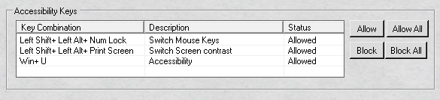

Notice that the current statuses of the key combinations are displayed.

Example Allow Accessibility key

It is a breeze to setup the keyboard filter with the UWF Wizard.
Two keystrokes and your key(s) or key combination(s) are allowed.
By default the thin client image has all key(s) and key combinations allowed.
So unless you have blocked them you will not need to allow them.
Shown below is the section that pertains to Accessibility keys.
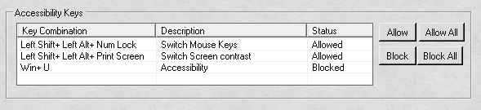

In the example above, you can see the "Win + U' is blocked.
To allow the "Win + U" combination, select the line and click the "Allow" button.
Once updated, you will notice the "Win + U" line is updated in real time to allowed
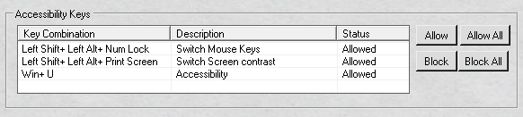

Example Block Accessibility key

It is a snap to setup the keyboard filter with the UWF Wizard.
Two keystrokes and your key(s) or key combination(s) are blocked.
By default the thin client image has all key(s) and key combinations allowed.
Shown below is the section that pertains to Accessibility keys.

In the example above, you can see the "Win + U' is allowed.
To allow the "Win + U" combination, select the line and click the "Block" button.
Once updated, you will notice the "Win + U" line is updated in real time to blocked.

Example Allow All Accessibility keys

It is a breeze to setup the keyboard filter with the UWF Wizard.
One click and all off the Accessibility keys are allowed.
By default the thin client image has all key(s) and key combinations allowed.
So unless you have blocked them you will not need to allow them.
Shown below is the section that pertains to Accessibility keys.
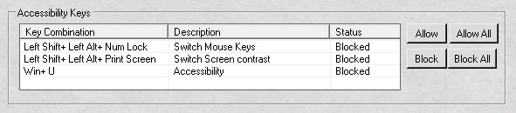

In the example above, you can see all the Accessibility Keys are blocked.
To allow all the Accessibility keys, click the "Allow All" button.
Once updated, you will notice the Accessibility keys are updated in real time to allowed

Example Block All Accessibility keys

It is simple to setup the keyboard filter with the UWF Wizard.
One click and all off the Accessibility keys are blocked.
By default the thin client image has all key(s) and key combinations allowed.
Shown below is the section that relates to Accessibility keys.

In the example above, you can see all the Accessibility Keys are allowed.
To block all the Accessibility keys, click the "Block All" button.
Once updated, you will notice the Accessibility keys are updated in real time to blocked

Application Keys
Application Keys

These common keys do application functions.
By default the key combinations here are the common ones.
Since these may not be well know we will explain what they do.
  - Alt + F4 – Close an application
  - Control + F4 – Closes a window
  - Escape - can often be used to get out of dialogs - it generally represents the pressing of the cancel button in these cases. The escape button can also be used to hide any output, find in files or find bar windows that are visible.
  - Menu - also known as the Application key is a key found on some Windows-oriented keyboards. This key is usually on the bottom-right of the keyboard, next to the Ctrl key, but it can be placed in a different location by keyboard manufacturers. It is usually depicted as a cursor hovering above a menu. The primary function of this key is to launch a context menu with the keyboard rather than by clicking the right mouse button: this is useful if mouse or a similar device is not available, or when the right mouse button is not present. The context menu is a menu that pops up when you right-click. The menu that you see, if any, is dependent on the context and function of the area that you right-clicked. When you use the Menu key, the context menu is shown for the area of the screen that your cursor is over at the point when the key is pressed.
  - Win + F1 - Brings up a Help window in many applications, including browsers, Microsoft Office and others.
By default these are enabled on the thin client image unless you disable them.
A snapshot of the section is shown below:
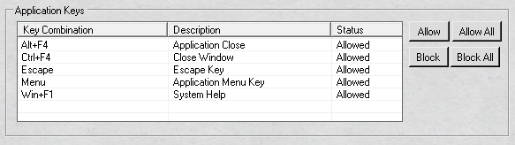

Notice that the current statuses of the key combinations are displayed.

Example Allow Application key

It is quick to setup the keyboard filter with the UWF Wizard.
Two keystrokes and your key(s) or key combination(s) are allowed.
By default the thin client image has all key(s) and key combinations allowed.
So unless you have blocked them you will not need to allow them.
Shown below is the section that pertains to Application keys.
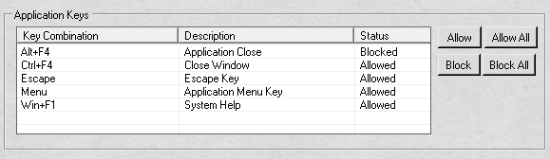

In the example above, you can see the "Alt + F4" is blocked.
To allow the "Alt = F4" combination, select the line and click the "Allow" button.
Once updated, you will notice the "Alt + F4" line is updated in real time to allowed
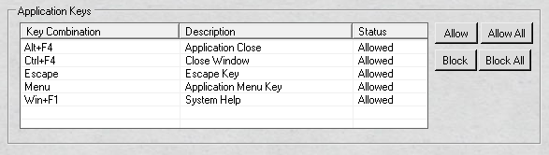

Example Block Application key

It is easy to setup the keyboard filter with the UWF Wizard.
Two keystrokes and your key(s) or key combination(s) are blocked.
By default the thin client image has all key(s) and key combinations allowed.
Shown below is the section that pertains to Application keys.

In the example above, you can see the "Alt + F4" is allowed.
To block the "Alt = F4" combination, select the line and click the "Block" button.
Once updated, you will notice the "Alt + F4" line is updated in real time to blocked

Example Allow All Application keys

It is fast to setup the keyboard filter with the UWF Wizard.
One click and all off the Application keys are allowed.
By default the thin client image has all key(s) and key combinations allowed.
So unless you have blocked them you will not need to allow them.
Shown below is the section that pertains to Application keys.
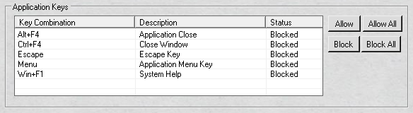

In the example above, you can see all the Application keys are blocked.
To allow all the Application keys, click the "Allow All" button.
Once updated, you will notice the Application keys are updated in real time to allowed
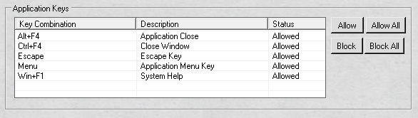

Example Block All Application keys

It is a breeze to setup the keyboard filter with the UWF Wizard.
One click and all off the Application keys are blocked.
By default the thin client image has all key(s) and key combinations allowed.
Shown below is the section that pertains to Application keys.

In the example above, you can see all the Application keys are allowed.
To block all the Application keys, click the "Block All" button.
Once updated, you will notice the Application keys are updated in real time to blocked.

Browser Keys
Browser Keys

This is the actual physical key found on certain Microsoft Keyboards not be confused with the buttons found in most web browsers or common keyboard shortcuts.
The browser keys are common functions that occur in the browser that you might want to block, again this is only the physical key on the keyboard.
The keys you can block/allow are:
  - Browser Back - Goes back to the previous page
  - Browser Favorites - Shows Browser Favorites Saved
  - Browser Forward - Goes a page forward
  - Browser Home - Displays the Home Page
  - Browser Refresh - Refreshes the current web page
  - Browser Search - Allows you to search
  - Browser Stop - Stops current load of page
By default these are enabled on the thin client image unless you disable them.
A snapshot of the section is shown below:
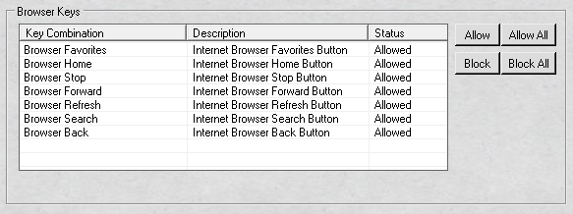

Notice that the current statuses of the key combinations are displayed.

Example Allow Browser key

It is fast to setup the keyboard filter with the UWF Wizard.
Two keystrokes and your key(s) or key combination(s) are allowed.
By default the thin client image has all key(s) and key combinations allowed.
So unless you have blocked them you will not need to allow them.
Shown below is the section that pertains to Browser keys.
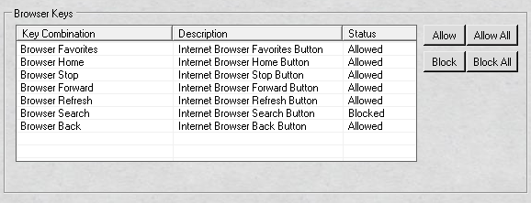

In the example above, you can see the "Browser Search" is blocked.
To allow the "Browser Search" key, select the line and click the "Allow" button.
Once updated, you will notice the "Browser Search" line is updated in real time to allowed

Example Allow Browser key

It is a snap to setup the keyboard filter with the UWF Wizard.
Two keystrokes and your key(s) or key combination(s) are blocked.
By default the thin client image has all key(s) and key combinations allowed.
Shown below is the section that pertains to Browser keys.

In the example above, you can see the "Browser Search" is allowed.
To block the "Browser Search" key, select the line and click the "Block" button.
Once updated, you will notice the "Browser Search" line is updated in real time to blocked.

Example Allow All Browser keys

It is fast to setup the keyboard filter with the UWF Wizard.
One keystroke and your key(s) or key combination(s) are allowed.
By default the thin client image has all key(s) and key combinations allowed.
So unless you have blocked them you will not need to allow them.
Shown below is the section that pertains to Browser keys.
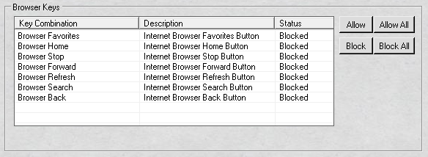

In the example above, you can see all the Browser keys are blocked.
To allow all the Browser keys, click the "Allow All" button.
Once updated, you will notice all the Browser keys are updated in real time to allowed.

Example Block All Browser keys

It is quick and easy to setup the keyboard filter with the UWF Wizard.
One keystroke and your key(s) or key combination(s) are allowed.
By default the thin client image has all key(s) and key combinations allowed.
Shown below is the section that pertains to Browser keys.

In the example above, you can see all the Browser keys are allowed.
To block all the Browser keys, click the "Block All" button.
Once updated, you will notice all the Browser keys are updated in real time to blocked.

Modifier Keys
Modifier Keys

In computing, a modifier key is a special key (or combination) on a computer keyboard that temporarily modifies the normal action of another key when pressed together.
By themselves, modifier keys usually do nothing; that is, pressing any of the Shift, Alt, or Ctrl keys alone does not (generally) trigger any action from the computer.
For example, in most keyboard layouts the Shift key combination Shift+A will produce a capital letter "A" instead of the default lower-case letter "a" (unless in Caps lock or Shift lock mode).
A combination of Alt+F4 in Microsoft Windows will close the active window; in this instance, Alt is the modifier key.
In contrast, pressing just Shift or Alt will probably do nothing unless assigned a specific function in a particular program (for example, activating input aids or the toolbar of the active window in Windows).
The modifier keys to block are the common one used in Microsoft Windows and most applications.
They are:
  - Alt - Modifier key used to change (alternate) the function of other pressed key
  - Ctrl - Modifier key which, when pressed in conjunction with another key, performs a special operation
  - Shift - Modifier key on a keyboard, used to type capital letters and other alternate "upper" characters.
  - Windows Key - Provides a central launching point for computer programs and performing other tasks
By default these are enabled on the thin client image unless you disable them.
A snapshot of the section is shown below:
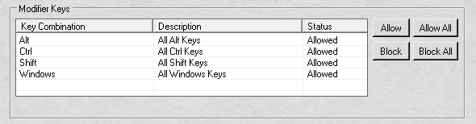

Notice that the current statuses of the key combinations are displayed.

Example Allow Modifier key

It is a breeze to setup the keyboard filter with the UWF Wizard.
Two keystrokes and your key(s) or key combination(s) are allowed.
By default the thin client image has all key(s) and key combinations allowed.
So unless you have blocked them you will not need to allow them.
Shown below is the section that pertains to Modifier keys.
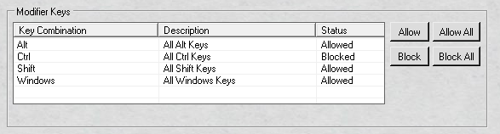

In the example above, you can see the "Ctrl" is blocked.
To allow the "Ctrl" key, select the line and click the "Allow" button.
Once updated, you will notice the "Ctrl" line is updated in real time to allowed

Example Block Modifier key

It is a snap to setup the keyboard filter with the UWF Wizard.
Two keystrokes and your key(s) or key combination(s) are blocked.
By default the thin client image has all key(s) and key combinations allowed.
Shown below is the section that pertains to Modifier keys.

In the example above, you can see the "Ctrl" is allowed.
To block the "Ctrl" key, select the line and click the "Block" button.
Once updated, you will notice the "Ctrl" line is updated in real time to blocked.

Example Allow All Modifier keys

It is fast to setup the keyboard filter with the UWF Wizard.
One keystroke and your key(s) or key combination(s) are allowed.
By default the thin client image has all key(s) and key combinations allowed.
So unless you have blocked them you will not need to allow them.
Shown below is the section that pertains to Modifier keys.
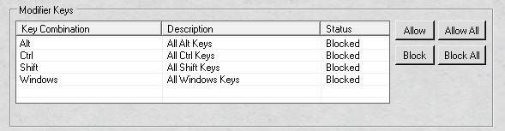

In the example above, you can see all the Modifier keys are blocked.
To allow all the Modifier keys, click the "Allow All" button.
Once updated, you will notice all the Modifier keys are updated in real time to allowed.

Example Block All Modifier keys

It is fast to setup the keyboard filter with the UWF Wizard.
One keystroke and your key(s) or key combination(s) are allowed.
By default the thin client image has all key(s) and key combinations allowed.
Shown below is the section that pertains to Modifier keys.

In the example above, you can see all the Modifier keys are allowed.
To allow all the Modifier keys, click the "Block All" button.
Once updated, you will notice all the Modifier keys are updated in real time to blocked.

Security Keys
Security Keys

Security keys are special key combinations used on a computer keyboard.
The operating system kernel, interacts directly with the hardware, detects whether the secure keys have been pressed.
When this event is detected, the kernel starts the trusted login processing.
The secure attention key is designed to make login spoofing impossible, as the kernel will suspend any program, including those masquerading as the computer's login process, before starting a trustable login operation.
In Microsoft Windows this is handled by the Win logon component.
Use of secure keys can also be required by the Windows User Account Control (UAC) prompt.
The security keys that can be blocked are the following:
  - Ctrl+Alt+Del - allows a user to see the status of all currently running programs and to terminate any of them, and also offers the options of shutting down, restarting, and so on
  - Shift+Ctrl+Esc - Brings up Task Manager
  - Windows Key + L - Lock workstation
By default these are enabled on the thin client image unless you disable them.
A snapshot of the section is shown below:

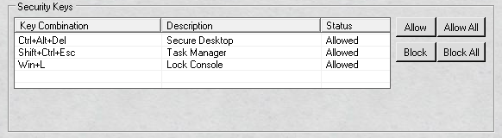

Notice that the current statuses of the key combinations are displayed.
Example Allow Security key

It is simple to setup the keyboard filter with the UWF Wizard.
Two keystrokes and your key(s) or key combination(s) are allowed.
By default the thin client image has all key(s) and key combinations allowed.
So unless you have blocked them you will not need to allow them.
Shown below is the section that pertains to Security keys.
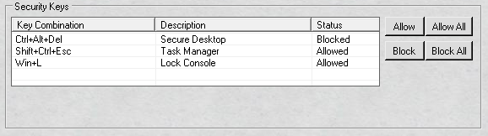

In the example above, you can see the "Ctrl + Alt + Del" is blocked.
To allow the "Ctrl + Alt + Del" key, select the line and click the "Allow" button.
Once updated, you will notice the "Ctrl + Alt + Del" line is updated in real time to allowed

Example Block Security key

It is a snap to setup the keyboard filter with the UWF Wizard.
Two keystrokes and your key(s) or key combination(s) are allowed.
By default the thin client image has all key(s) and key combinations allowed.
Shown below is the section that pertains to Security keys.

In the example above, you can see the "Ctrl + Alt + Del" is allowed.
To block the "Ctrl + Alt + Del" key, select the line and click the "Block" button.
Once updated, you will notice the "Ctrl + Alt + Del" line is updated in real time to blocked.

Example Allow All Security keys

It is a breeze to setup the keyboard filter with the UWF Wizard.
One keystroke and your key(s) or key combination(s) are allowed.
By default the thin client image has all key(s) and key combinations allowed.
So unless you have blocked them you will not need to allow them.
Shown below is the section that pertains to Security keys.
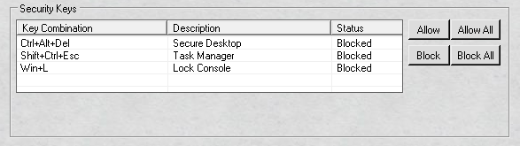

In the example above, you can see all the Security keys are blocked.
To allow all the Security keys, click the "Allow All" button.
Once updated, you will notice all the Security keys are updated in real time to allowed.

Example Block All Security keys

It is quick to setup the keyboard filter with the UWF Wizard.
One keystroke and your key(s) or key combination(s) are blocked.
By default the thin client image has all key(s) and key combinations allowed.
Shown below is the section that pertains to Security keys.

In the example above, you can see all the Security keys are allowed.
To block all the Security keys, click the "Block All" button.
Once updated, you will notice all the Security keys are updated in real time to blocked.

Keyboard Filter - Shell Keys
Keyboard Filter - Shell Keys

The shells keys change or toggle different operations in the Windows shell and applications.
Some are common known shortcuts others are not.
Below is a list of the shortcut with its function.
  - Alt[+Shift]+Tab – Switch task
  - Alt+Space – Application menus
  - Ctrl[+Shift]+Tab – Switch window
  - Ctrl+Esc – Start menu
  - Ctrl+Win+F – Find computers
  - Win[+Shift]+M – Minimize all windows
  - Win[+Shift]+P – Toggle display
  - Win{+Shift]+Period – Move modern shells gutter to left or right
  - Win[+Shift]+Space – Switch input language and toggle keyboard layout
  - Win[+Shift]+Tab – Cycle through applications
  - Win[+Shift]+V – Cycle through toast notifications
  - Win+B – Set focus in the notification area
  - Win+Break – System properties
  - Win+C – Open modern shells charm menu
  - Win+Comma – Temporarily peek at windows desktop
  - Win+D – Show desktop
  - Win+Divide – Open IME
  - Win+Down – Minimize current window
  - Win+E – Start explorer
  - Win+Enter – Start Narrator
  - Win+Escape – Close magnifier application
  - Win+F – Find Dialog
  - Win+H – Open share charm
  - Win+Home – Minimize/restore of non-active windows
  - Win+I – Open modern shells settings charms bar
  - Win+J – Swap between snapped and filled applications
  - Win+K – Open the connect charm
  - Win+Left – Dock current window to the left
  - Win+Minus – Magnifier zoom out
  - Win+O – Lock the device orientation
  - Win+PageDown – Cycle modern shell to the next right monitor
  - Win+PageUp - Cycle modern shell to the next left monitor
  - Win+Plus – Magnifier zoom in
  - Win+Q – Open search charm
  - Win+R – Run dialog
  - Win+Right – Dock current window to the right
  - Win+Shift+Down – Restore windows current vertical size
  - Win+Shift+Left – Move current window to the left monitor
  - Win+Shift+Right – Move current window to the right monitor
  - Win+Shift+Up – Maximize current windows vertical size
  - Win+T – Focus on taskbar and cycle through programs
  - Win+Up – Maximize current window
  - Win+W – Open the settings search charm
  - Win+Z – Open the application bar
By default in the thin client image the Shell Keys are allowed.
Below is a snap shot of the Shell Key section:
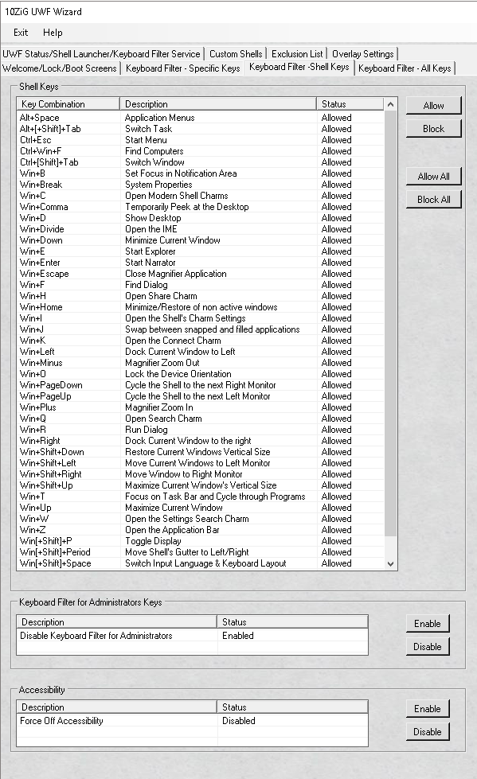

The tab above also contains two other sections Keyboard Filter Administrators Keys and Accessibility.
The Keyboard Filter Administrator Keys gives you the ability to disable the keyboard filter for all users belonging to the Administrator group.
That means that all other Microsoft groups would have the keyboard filter active except the administrator accounts.
This will allow the group to navigate past KIOSK setups and the ability to update or make any changes to Microsoft Windows.
However, if you do want the administrator group to have the keyboard filter enforced, that can be done as well.
This will prevent any back door issues in a true KIOSK environment.
This is the section is referenced above.
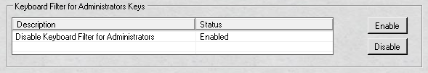

The status of the Administrator Keyboard Filter is reflected in real time.
By default the keyboard filter is enabled for the Administrator group, which means that the keyboard filter is not in effect for the Administrator group or the Administrator account.
The last section on the tab is Accessibility.
By default, Ease of Access features are enabled in the thin client image.
If Sticky Keys are enabled, a user can bypass the Keyboard Filter in certain situations.
You can configure the Keyboard Filter to disable all Ease of Access features and prevent users from enabling them.
You can enable Ease of Access features for administrator accounts, while still disabling them for standard user accounts, by making sure that Keyboard Filter is disabled for administrator accounts.

Below is a snap shot of the section:

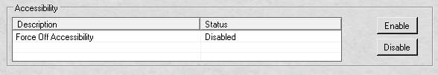

Shell Keys
Shell Keys

The shells keys change or toggle different operations in the Windows shell and applications.
Some are common known shortcuts others are not.
Below is a list of the shortcut with its function.
  - Alt - Modifier key used to change (alternate) the function of other pressed key
  - Alt[+Shift]+Tab – Switch task
  - Alt+Space – Application menus
  - Ctrl[+Shift]+Tab – Switch window
  - Ctrl+Esc – Start menu
  - Ctrl+Win+F – Find computers
  - Win[+Shift]+M – Minimize all windows
  - Win[+Shift]+P – Toggle display
  - Win{+Shift]+Period – Move modern shells gutter to left or right
  - Win[+Shift]+Space – Switch input language and toggle keyboard layout
  - Win[+Shift]+Tab – Cycle through applications
  - Win[+Shift]+V – Cycle through toast notifications
  - Win+B – Set focus in the notification area
  - Win+Break – System properties
  - Win+C – Open modern shells charm menu
  - Win+Comma – Temporarily peek at windows desktop
  - Win+D – Show desktop
  - Win+Divide – Open IME
  - Win+Down – Minimize current window
  - Win+E – Start explorer
  - Win+Enter – Start Narrator
  - Win+Escape – Close magnifier application
  - Win+F – Find Dialog
  - Win+H – Open share charm
  - Win+Home – Minimize/restore of non-active windows
  - Win+I – Open modern shells settings charms bar
  - Win+J – Swap between snapped and filled applications
  - Win+K – Open the connect charm
  - Win+Left – Dock current window to the left
  - Win+Minus – Magnifier zoom out
  - Win+O – Lock the device orientation
  - Win+PageDown – Cycle modern shell to the next right monitor
  - Win+PageUp - Cycle modern shell to the next left monitor
  - Win+Plus – Magnifier zoom in
  - Win+Q – Open search charm
  - Win+R – Run dialog
  - Win+Right – Dock current window to the right
  - Win+Shift+Down – Restore windows current vertical size
  - Win+Shift+Left – Move current window to the left monitor
  - Win+Shift+Right – Move current window to the right monitor
  - Win+Shift+Up – Maximize current windows vertical size
  - Win+T – Focus on taskbar and cycle through programs
  - Win+Up – Maximize current window
  - Win+W – Open the settings search charm
  - Win+Z – Open the application bar
By default in the thin client image the Shell Keys are allowed.
Unless you change them to blocked you will not need to do anything.
Below is a snap shot of the Shell Key section:
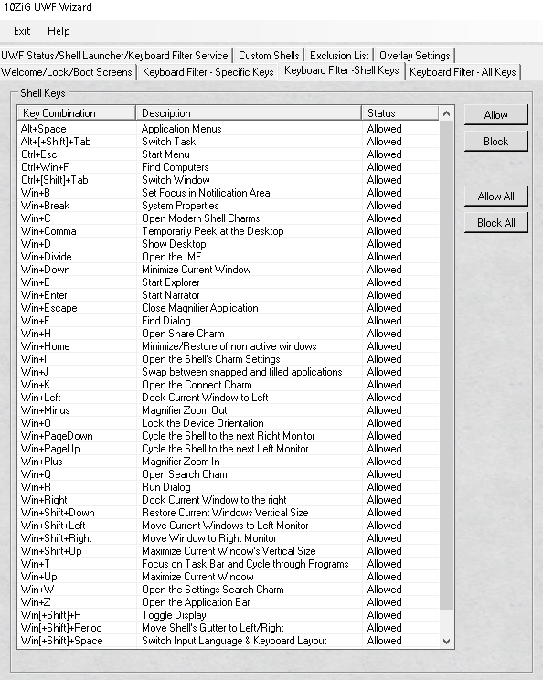

Example Allow Shell key

It is quick and fast to setup the keyboard filter with the UWF Wizard.
Two keystrokes and your key(s) or key combination(s) are allowed.
By default the thin client image has all key(s) and key combinations allowed.
So unless you have blocked them you will not need to allow them.
Shown below is the section that pertains to Shell keys.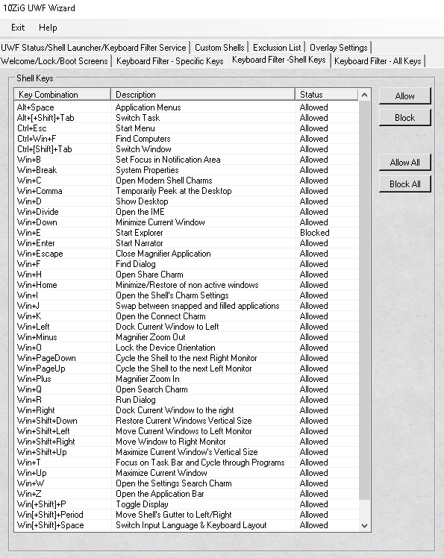

In the example above, you can see the "Win + E" is blocked.
To allow the "Win + E" key, select the line and click the "Allow" button.
Once updated, you will notice the "Win + E" line is updated in real time to allowed.

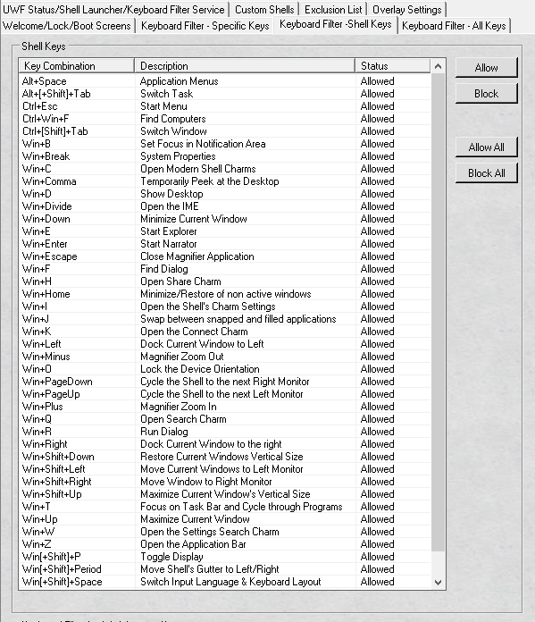

Example Block Shell key

It is a breeze to setup the keyboard filter with the UWF Wizard.
Two keystrokes and your key(s) or key combination(s) are blocked.
By default the thin client image has all key(s) and key combinations allowed.
Shown below is the section that pertains to Shell keys.

In the example above, you can see the "Win + E" is allowed.
To allow the "Win + E" key, select the line and click the "Block" button.
Once updated, you will notice the "Win + E" line is updated in real time to blocked.

Example Allow All Shell keys

It is simple to setup the keyboard filter with the UWF Wizard.
One keystroke and your key(s) or key combination(s) are allowed.
By default the thin client image has all key(s) and key combinations allowed.
So unless you have blocked them you will not need to allow them.
Shown below is the section that pertains to Shell keys.
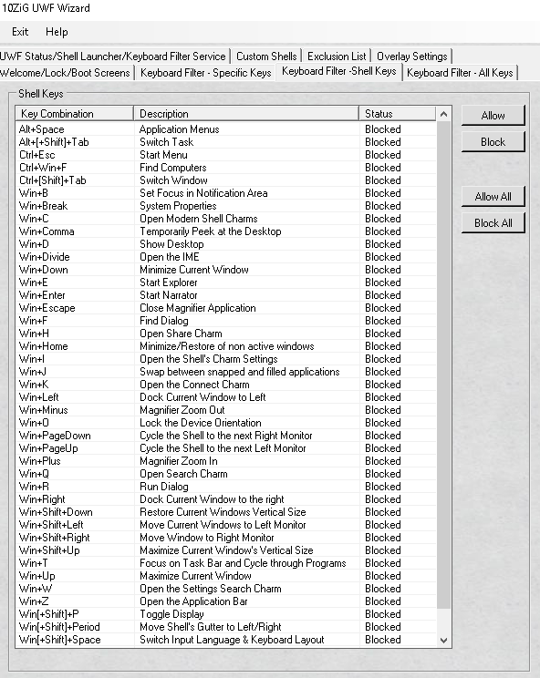

In the example above, you can see all the Shell keys are blocked.
To allow all the Shell keys, click the "Allow All" button.
Once updated, you will notice all the Shell keys are updated in real time to allowed.

Example Block All Shell keys

It is fast to setup the keyboard filter with the UWF Wizard.
One keystroke and your key(s) or key combination(s) are blocked.
By default the thin client image has all key(s) and key combinations allowed.
Shown below is the section that pertains to Shell keys.

In the example above, you can see all the Shell keys are allowed.
To block all the Shell keys, click the "Block All" button.
Once updated, you will notice all the Shell keys are updated in real time to blocked.

Enable/Disable Filter Admins
Enable/Disable Filter Admins

The UWF Wizard gives you the best of two worlds.
You have the ability to disable the keyboard filter for all users belonging to the Administrator group.
That means that all other Microsoft groups would have the keyboard filter active except the administrator accounts.
This will allow the group to navigate past KIOSK setups and the ability to update or make any changes to Microsoft Windows.
However, if you do want the administrator group to have the keyboard filter enforced, that can be done as well.
This will prevent any back door issues in a true KIOSK environment.
This is the section is referenced above.

The status of the Administrator Keyboard Filter is reflected in real time.
By default the keyboard filter is enabled for the Administrator group on the thin client image, which means it is not enforced for the Administrator group or the Administrator account.

Example Enabling Keyboard Filter Administrator Group

It is straightforward to enable the keyboard filter for the administrator accounts.
By default the keyboard filter is enabled in the thin client image.
If have not disabled it you will not need to change it.
If you want to enable it for the administrator group an example is shown below.
Please take note that the user will need to log out and back in for the change to take effect.
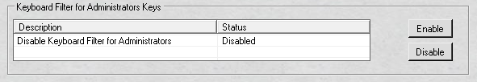

In the example above, you can see the "Disable Keyboard For Administrators" is disabled, which mean that the keyboard filter is in effect for all users including anyone who is an Administrator or even the Administrator account itself.
To enable or block the filter for the administrator group, select the line and click the "Enable" button.
Once updated, you will notice the "Disable Keyboard Filter for Administrators" line is updated in real time to enabled.
Once enabled you will need to log off and log back in for the keyboard filter to have no effect.
When the "Disable Keyboard Filter for Administrators" is "enabled" it does not block any keys that are disallowed.

Example Disabling Keyboard Filter Administrator Group

It is a breeze to enable or disable the keyboard filter for the administrator accounts.
By default the keyboard filter is enabled in the thin client image.
Therefore, the keyboard filter has no bearing on anyone in the Administrator group or the Administrator account itself. Any blocked key(s) and/or key combinations will be ignored.
If you want to disable it for the administrator group an example is shown below.
Please take note that the user will need to log out and back in for the change to take effect.

In the example above, you can see the "Disable Keyboard For Administrators" is enabled, which mean that the keyboard filter is not in effect for all users including anyone who is an Administrator or even the Administrator account itself.
To enable the filter for the administrator group, select the line and click the "Disable" button.
Once updated, you will notice the "Disable Keyboard Filter for Administrators" line is updated in real time to enabled.

Once disabled and you have logged off and log back in all key(s) and key combinations are in effect for the Administrator group and even the Administrator account.

Enable/Disable Accessibility
Enable/Disable Accessibility

By default, Accessibility is allowed on the thin client image.
So if "Sticky Keys" are enabled, a user can bypass the keyboard filter in certain situations.
You can configure the keyboard filter to disable all "Ease of Access" features and prevent users from enabling them.
You can enable Ease of Access features for administrator accounts, while still disabling them for standard user accounts, by making sure that Keyboard Filter is disabled for administrator accounts.

Below is a snap shot of the section:

Example Enabling Accessibility

It is a snap to enable the "Force Off Accessibility" with the 10ZiG UWF Wizard.
By default the "Force Off Accessibility" is disabled in the thin client image, which means it is allowed for everyone to use.
See screen shot below:

If you want to enable then select the line that says "Force Off Accessibility" and click the "Enable" button.
See screen shot below:
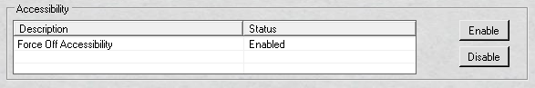

Please note, the status is changed in real time.
With this feature enabled nobody will be able to use Accessibility even the administrator group or even the administrator account, unless you have the feature "Disable Keyboard Filter Administrator Group" enabled.

Example Disabling Accessibility

It is a snap to disable the "Force Off Accessibility" with the 10ZiG UWF Wizard.
By default the "Force Off Accessibility" is disabled in the thin client image, which means it is allowed for everyone to use.
So unless you have changed it, you will not need to change it.
See screen shot below:

If you want to disable then select the line that says "Force Off Accessibility" and click the "Disable" button.
See screen shot below:

Please note, the status is changed in real time.
With this feature disabled everyone will have access to the Accessibility feature in Windows.

Keyboard Filter - All Keys
Keyboard Filter - All Keys

The "Keyboard Filter - All Keys" tab allows you to allow, block, allow all or block all keys board shortcuts in Accessibility, Application, Browser, Modifier, Security and Shell keys all from one tab.

When the configuration form is accessed the current status is displayed in real time.

The tab incorporates all of the key(s) and key combinations in an alphabetical order for ease to disable/enable without having to search where to find them.
Since these may not be well know we will explain what they do.
  - Alt - Modifier key used to change (alternate) the function of other pressed key
  - Alt + F4 – Close an application
  - Alt[+Shift]+Tab – Switch task
  - Alt+Space – Application menus
  - Browser Back - Goes back to the previous page
  - Browser Favorites - Shows Browser Favorites Saved
  - Browser Forward - Goes a page forward
  - Browser Home - Displays the Home Page
  - Browser Refresh - Refreshes the current web page
  - Browser Search - Allows you to search
  - Browser Stop - Stops current load of page
  - Control + F4 – Closes a window
  - Ctrl - Modifier key which, when pressed in conjunction with another key, performs a special operation
  - Ctrl[+Shift]+Tab – Switch window
  - Ctrl+Alt+Del - allows a user to see the status of all currently running programs and to terminate any of them, and also offers the options of shutting down, restarting, and so on
  - Ctrl+Esc – Start menu
  - Ctrl+Win+F – Find computers
  - Escape - Can often be used to get out of dialogs and can also be used to hide any output, find in files or find bar windows that are visible.
  - Left Shift + Left Alt + NumLock – Turns on/off mouse keys
  - Left Shift + Left Alt + Print Screen – Toggles on/off High Contrast Mode
  - Menu - Also known as the Application key is a key found on some Windows-oriented keyboards.
  - Shift - Modifier key on a keyboard, used to type capital letters and other alternate "upper" characters.
  - Shift+Ctrl+Esc - Task Manager
  - Shift - Modifier key on a keyboard, used to type capital letters and other alternate "upper" characters.
  - Win + F1 - Brings up a Help window in many applications, including browsers, Microsoft Office and others
  - Win + U – Turns on Utility Manager
  - Win[+Shift]+M – Minimize all windows
  - Win[+Shift]+P – Toggle display
  - Win{+Shift]+Period – Move modern shells gutter to left or right
  - Win[+Shift]+Space – Switch input language and toggle keyboard layout
  - Win[+Shift]+Tab – Cycle through applications
  - Win[+Shift]+V – Cycle through toast notifications
  - Win+B – Set focus in the notification area
  - Win+Break – System properties
  - Win+C – Open modern shells charm menu
  - Win+Comma – Temporarily peek at windows desktop
  - Win+D – Show desktop
  - Win+Divide – Open IME
  - Win+Down – Minimize current window
  - Win+E – Start explorer
  - Win+Enter – Start Narrator
  - Win+Escape – Close magnifier application
  - Win+F – Find Dialog
  - Win+H – Open share charm
  - Win+Home – Minimize/restore of non-active windows
  - Win+I – Open modern shells settings charms bar
  - Win+J – Swap between snapped and filled applications
  - Win+K – Open the connect charm
  - Win+Left – Dock current window to the left
  - Win+Minus – Magnifier zoom out
  - Win+O – Lock the device orientation
  - Win+PageDown – Cycle modern shell to the next right monitor
  - Win+PageUp - Cycle modern shell to the next left monitor
  - Win+Plus – Magnifier zoom in
  - Win+Q – Open search charm
  - Win+R – Run dialog
  - Win+Right – Dock current window to the right
  - Win+Shift+Down – Restore windows current vertical size
  - Win+Shift+Left – Move current window to the left monitor
  - Win+Shift+Right – Move current window to the right monitor
  - Win+Shift+Up – Maximize current windows vertical size
  - Win+T – Focus on taskbar and cycle through programs
  - Win+Up – Maximize current window
  - Win+W – Open the settings search charm
  - Win+Z – Open the application bar
  - Windows Key + L - Lock Workstation
  - Windows Key - Provides a central launching point for computer programs and performing other tasks
The key(s) or key combinations are blocked immediately with no reboot needed.

Below is a screen shot of the "Keyboard Filter - All Keys" tab.

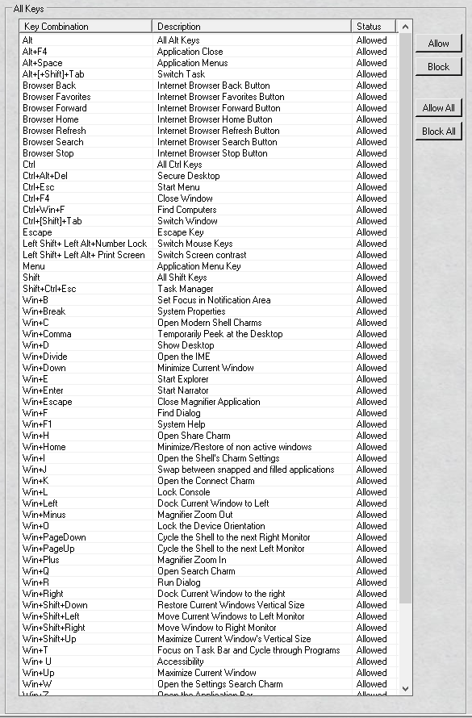

Example Allow key - All Key

It is quick and easy to setup the keyboard filter with the UWF Wizard.
Two keystrokes and your key(s) or key combination(s) are allowed.
By default the thin client image has all key(s) and key combinations allowed.
So unless you have blocked them you will not need to allow them.
Shown below is the section that pertains to the "All Keys".
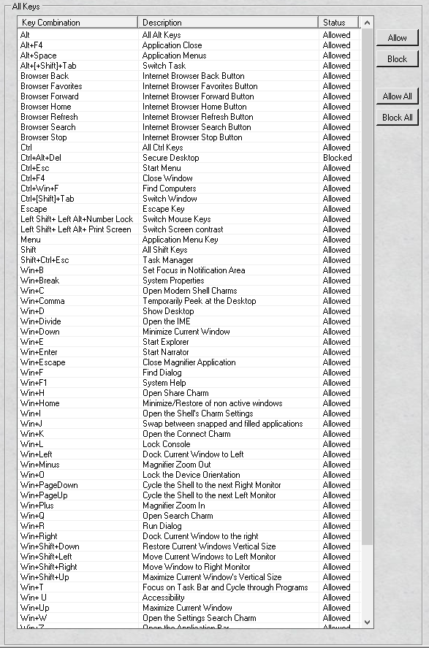

In the example above, you can see the "Ctrl + Alt + Del" is blocked.
To allow the "Ctrl + Alt + Del" key, select the line and click the "Allow" button.
Once updated, you will notice the "Ctrl + Alt + Del" line is updated in real time to allowed

Example Block key - All Key

It is a snap to setup the keyboard filter with the UWF Wizard.
Two keystrokes and your key(s) or key combination(s) are allowed.
By default the thin client image has all key(s) and key combinations allowed.
So unless you have blocked them you will not need to allow them.
Shown below is the section that pertains to the "All Keys".

In the example above, you can see the "Ctrl + Alt + Del" is allowed.
To block the "Ctrl + Alt + Del" key, select the line and click the "Allow" button.
Once updated, you will notice the "Ctrl + Alt + Del" line is updated in real time to blocked.

Example Allow All - All keys

It is a breeze to setup the keyboard filter with the UWF Wizard.
One keystroke and your key(s) or key combination(s) are allowed.
By default the thin client image has all key(s) and key combinations allowed.
So unless you have blocked them you will not need to allow them.
Shown below is the section that pertains to All Keys tab.
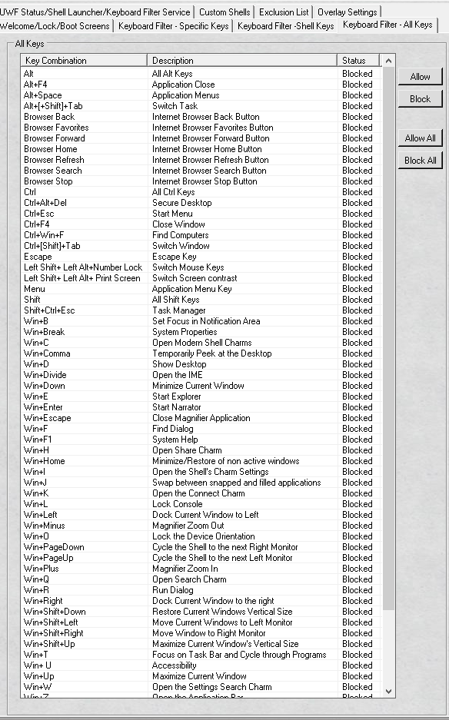

In the example above, you can see all the "All Keys" are blocked.
To allow all the "All Keys", click the "Allow All" button.
Once updated, you will notice all the "All Keys" are updated in real time to allowed.

Example Block All - All keys

It is a simple to setup the keyboard filter with the UWF Wizard.
One keystroke and your key(s) or key combination(s) are allowed.
By default the thin client image has all key(s) and key combinations allowed.
So unless you have blocked them you will not need to allow them.
Shown below is the section that pertains to All Keys tab.

In the example above, you can see all the "All Keys" are allowed.
To block all the "All Keys", click the "Block All" button.
Once updated, you will notice all the "All Keys" are updated in real time to blocked.

Glossary
Glossary

Unified Write Filter - helps protect your physical storage media, including most standard writable storage types that are supported by Microsoft Windows, such as physical hard disks, solid-state drives, internal USB devices, external SATA devices, and so on. You can also use UWF to make read-only media appear to the OS as a writable volume. Please note that you cannot use UWF to protect external removable drives, USB devices or flash drives.
UWF intercepts all write attempts to a protected volume and redirects those write attempts to a virtual overlay. This improves the reliability and stability of your device and reduces the wear on write-sensitive media, such as flash memory media like solid-state drives.
The overlay does not mirror the entire volume, but dynamically grows to keep track of redirected writes. Generally the overlay is stored in system memory, although you can cache a portion of the overlay on a physical volume. Please note that UWF fully supports the NTFS file system; however, during device startup, NTFS file system journal files can write to a protected volume before UWF has loaded and started protecting the volume.

Shell Launcher - replaces the default Windows 10 shell with a custom shell. You can use any application or executable as your custom shell, such as a command window or a custom dedicated application.
Warning - You may specify any executable file to be the default shell except C:\Windows\System32\Eshell.exe. Using Eshell.exe as the default shell will result in a blank screen after user signs in.
You can also configure Shell Launcher to launch different shell applications for different users or user groups. Please note that you cannot use Shell Launcher to launch a Universal Windows application as a custom shell.
Shell Launcher processes the Run and RunOnce registry keys before starting the custom shell, so your custom shell doesn’t need to handle the automatic startup of other applications and services.
Shell Launcher also handles the behavior of the system when your custom shell exits. You can configure the shell exit behavior if the default behavior does not meet your needs.

KIOSK Mode - is the system and user interface software designed for an interactive kiosk or Internet kiosk. Kiosk software locks down the application in order to protect the kiosk from users. Kiosk software may offer remote monitoring to manage multiple kiosks from another location. Email or text alerts may be automatically sent from the kiosk for daily activity reports or generated in response to problems detected by the software. Other features allow for remote updates of the kiosk's content and the ability to upload data such as kiosk usage statistics. Kiosk software is used to manage a touch screen, allowing users to touch the monitor screen to make selections. A virtual keyboard eliminates the need for a computer keyboard.

Overlay Type - You can configure UWF to store the overlay either entirely in RAM (RAM-based), or to store the overlay in a pre-allocated file on the system volume (disk-based).
All information in the overlay is lost after a device restarts or experiences a power loss, regardless of how the overlay is stored.
The overlay is created the first time the file system mounts a volume. Each time that UWF redirects a write attempt to the overlay, the disk sectors that would be modified are copied to the overlay. Because file systems do not access individual sectors on a volume, but rather clusters of sectors, the entire cluster that would be modified is copied to the overlay.
When the file system erases or deletes files that do not exist on the protected volume, UWF removes unneeded clusters from the overlay and returns the freed resources to the available pool. This primarily affects the overlay size when temporary files are created and then deleted.

RAM Based Overlay - In a RAM-based overlay, all overlay information is kept in system memory. Because RAM-based overlays reduce access to the physical volume, they can reduce wear on write-sensitive media. RAM-based overlays can be used with read-only media.
As applications continue to write to protected volumes, a RAM-based overlay consumes available free RAM until the overlay reaches a specified maximum size or reaches critically low levels of available RAM, which requires that the system be restarted. Because RAM is typically much more expensive than disk space, available RAM usually limits how long your system can operate before needing to be restarted.
Please note when you use a RAM-based overlay, make sure to leave enough available RAM to meet at least the minimum required RAM for the system to run. For example, if your OS requires at least 2 GB of RAM, and your device has 4 GB of RAM, set the maximum size of the overlay to 2 GB or less.

Disk Based Overlay - In a disk-based overlay, UWF uses a pre-allocated file created on the system volume to increase the available space for the overlay. The maximum size of the overlay is limited to the size of the disk file. The disk file does not dynamically grow in size, but must be pre-allocated on the volume. Disk-based overlays require a Maximum Overlay Size of at least 1024 MB.

Maximum Size Overlay - The Maximum Size for the overlay can be set here and it does not take effect until the thin client is rebooted. The size is in megabytes. The default size set in the thin client image is 1024 MB. Be careful to not set the maximum cache size of the overlay past what is available.

Warning Threshold Size Overlay - The unified write filter sends a warning threshold notification event when the unified write filter overlay size reaches or exceeds this value. The warning threshold size is set in megabytes. The default size in the thin client image is 512 megabytes.

Critical Threshold Size Overlay - The unified write filter sends a critical threshold notification event when the unified write filter overlay size reaches or exceeds this value. The critical threshold size is set in megabytes. The default size in the thin client image is 1024 megabytes.

Overlay Exhaustion - If the size of the overlay is close to or equal to the maximum overlay size, any write attempts will fail, returning an error indicating that there is not enough space to complete the operation. If the overlay on your device reaches this state, your device may become unresponsive and sluggish, and you may need to restart your device.
When Windows shuts down, it attempts to write a number of files to the disk. If the overlay is full, these write attempts fail, causing Windows to attempt to rewrite the files repeatedly until UWF can determine that the device is trying to shut down and resolve the issue. Attempting to shut down by using normal methods when the overlay is full or near to full can result in the device taking a long time, in some cases up to an hour or longer, to shut down.

Consumption Size Overlay - current consumption space being used by the UWF overlay. Please note that UWF must be enabled to see a value.

Available Space Size Overlay - - current available space that can be used by the UWF overlay. Please note that UWF must be enabled to see a value

SID – a unique, immutable identifier of a user, user group, or other security principal. A security principal has a single SID for life (in a given domain), and all properties of the principal, including its name, are associated with the SID.

Shell – User Interface that provides users with access to a wide variety of objects necessary for running applications and managing the operating system.

UWF Servicing - When a device is protected with UWF, you must use UWF servicing mode commands to service the device and apply updates to an image. You can use UWF servicing mode to apply Windows updates, antimalware signature file updates, and custom software or third-party software updates.

Keyboard Filter – a program that allows you to suppress undesirable key presses or key combinations. Normally, a customer can use certain Microsoft Windows key combinations like Ctrl+Alt+Delete or Ctrl+Shift+Tab to alter the operation of a device by locking the screen or using Task Manager to close a running application. This may not be desirable if your device is intended for a dedicated purpose.
The Keyboard Filter feature works with physical keyboards, the Windows on-screen keyboard and the touch keyboard. Keyboard Filter also detects dynamic layout changes, such as switching from one language set to another, and continues to suppress keys correctly, even if the location of suppressed keys has changed on the keyboard layout.

Accessibility Keys - common keys or shortcuts that bring up accessibility functions

Application Keys - common keys that allow you to do application functions

Browser Keys - This is the actual physical keys found on certain Microsoft Keyboards not be confused with the buttons found in most web browsers or common keyboard shortcuts. The browser keys are common functions that occur in the browser.

Modifier Keys - is a special key (or combination) on a computer keyboard that temporarily modifies the normal action of another key when pressed together. By themselves, modifier keys usually do nothing; that is, pressing any of the ⇧ Shift, Alt, or Ctrl keys alone does not (generally) trigger any action from the computer.
For example, in most keyboard layouts the Shift key combination ⇧ Shift+A will produce a capital letter "A" instead of the default lower-case letter "a" (unless in Caps lock or Shift lock mode). A combination of Alt+F4 in Microsoft Windows will close the active window; in this instance, Alt is the modifier key. In contrast, pressing just ⇧ Shift or Alt will probably do nothing unless assigned a specific function in a particular program (for example, activating input aids or the toolbar of the active window in Windows).

Security Keys - are special key combinations used on a computer keyboard. The operating system kernel, interacts directly with the hardware, detects whether the secure keys have been pressed. When this event is detected, the kernel starts the trusted login processing.
The secure attention key is designed to make login spoofing impossible, as the kernel will suspend any program, including those masquerading as the computer's login process, before starting a trustable login operation. In Microsoft Windows this is handled by the Winlogon component. Use of secure keys can also be required by the Windows User Account Control (UAC) prompt.

Shell Keys - change or toggle different operations in the Windows shell and applications.

Page File - Pagefile in Windows 10 is a hidden system file with the .SYS extension that is stored on your computer’s system drive (usually C:\). The Page file allows the computer to perform smoothly by reducing the workload of the physical memory, or RAM. Simply put, every time you open more applications than the RAM on your PC can accommodate, the programs already present in the RAM are automatically transferred to the Page file. This process is technically called Paging. Because the Page file works as a secondary RAM, many times it is also referred to as Virtual Memory.
The minimum and maximum size of the Page file can be up to 1.5 times and 4 times of the physical memory that your computer has, respectively.

